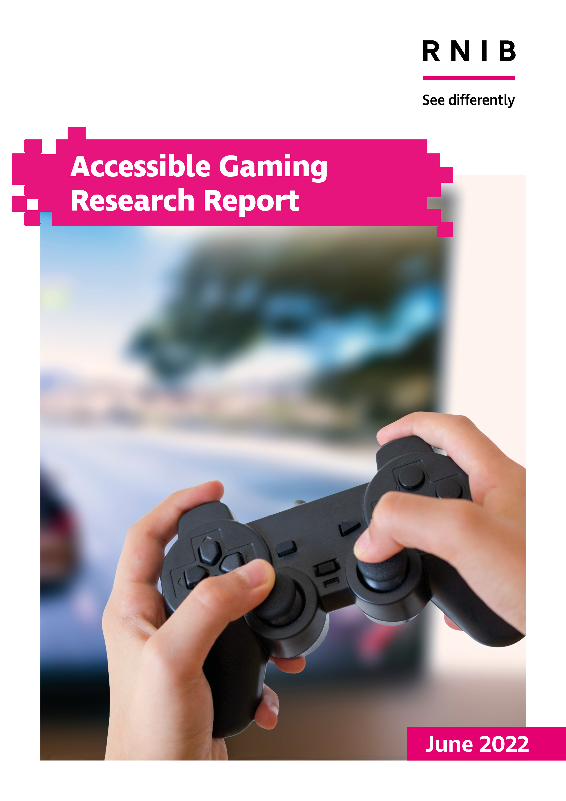



**Accessible Gaming Research Report**

May 2022

**By:**

**RNIB Team**

Sonali Rai, Broadcast Manager

John Paton, Innovation and Technology Officer

Sabine Croxford, User experience Evaluator

Lori Di Bon-Conyers, User experience Evaluator

Emma Edwards, Senior Research Analyst

Alison Long, Head of Consumer and Business Section

Robin Spinks, Senior Manager, Inclusive Design and Innovation

Jonny Marshall, Research Assistant

**i2 Media Research (Goldsmiths, University of London) Team**

Professor Jonathan Freeman, Managing Director (i2) and Academic Lead Knowledge Exchange (Goldsmiths)

Leah Kurta, Innovation Lead

Lewis Turner-Brown, Research Psychologist

Stephanie Miller, Research Psychologist

**University of Edinburgh, Moray House School of Education and Sport**

Professor John Ravenscroft, Director of the Scottish Sensory Centre

RNIB (Royal National Institute of Blind People)

Media and Culture Team, 105 Judd Street, London, WC1H 9NE

Email: [gaming@rnib.org.uk](mailto:gaming@rnib.org.uk)

Table of Contents

Introduction 5

Acknowledgments 6

Executive Summary 7

Key findings from user study 7

Key findings from industry consultation 8

Recommendations 9

Recommended future research 10

Chapter 1: Quantitative study (Prepared by i2 Media Research for RNIB) 10

1.1 Introduction 10

1.2 Research questions 10

1.3 Methodology 11

1.3.1 Procedure 11

1.3.2. Sample 12

1.4 Results 19

1.4.1 Motivation and barriers to playing video games 19

1.4.2. User perspectives on accessibility 29

1.4.3 Platform preference, desired access features and adaptations 31

1.5 Conclusions and recommendations 35

1.5.1 Research recommendations 35

Chapter 2: Qualitative study 36

2.1 Methodology 36

2.1.1 Participants 36

2.2. Results 40

2.2.1 Introduction to gaming 40

2.2.2 Impact of sight loss on gaming 40

2.2.3 Types of games 42

2.2.4 Prioritising access features 45

2.2.5 Designing for inclusion 49

2.3 Conclusion 51

Chapter 3: Industry survey 52

3.1 Methodology 52

3.2 Developers’ survey 53

3.2.1 Understanding the needs of gamers with sight loss 54

3.2.2 Building access features into a game 55

3.2.3. Designing for varying degrees of vision impairment 57

3.2.4 Integrating accessibility into the design 60

3.2.5 Motivation for making games accessible 69

3.3 Engines and middleware survey 75

3.3.1 Understanding the needs of gamers with sight loss 76

3.3.2 Factors that influence accessibility for game engines and middleware 82

3.4 Platforms and devices survey 86

3.5 Conclusion 92

Appendix 1 (Quantitative study from i2 Media Research) 94

# Introduction

This is RNIB’s first Accessible Gaming Report, a research report for the games industry, policy makers, advocates, consumers, and academics. The main objectives of the report are to review experiences of people with vision impairments while playing video games and to establish barriers for playing different types of games on different platforms.

We have taken a comprehensive approach, surveying people who play games now and those who would like to play games but don’t, and those who used to play games but no longer do. A small sample of sighted gamers was also included to understand their use of features such as subtitles, high contrast, and large fonts which are frequently used by people with vision impairments. In addition, inputs were sought from the games industry, developers of engines and middleware, and lastly, platforms that are used to deliver the experiences to consumers. While this report covers some of the main points that would be of significant interest to the games industry and other stakeholders, extensive data will subsequently be published in papers, articles, and specialist blogs.

The report is divided into three chapters:

* Chapter one examines the results from the quantitative survey completed by over 500 gamers, looking at their preferences and habits in relation to playing video games.
* Chapter two focuses on the feedback gathered from gamers with vision impairments in interviews, sharing their coping strategies and which aspects of video games they would like to see prioritised to make playing games accessible and enjoyable.
* Chapter three has a review of the feedback gathered from the games industry, outlining the key results gathered from game developers and those working with the gaming engines, middleware, and platforms.

RNIB’s Accessible Gaming Report addresses our commitment to undertake and share consumer research in areas that are of interest to people with vision impairments. While we encourage the games industry and other stakeholders to engage with this user group directly, we understand this may not be possible for all. Therefore, for them, we hope this report will also serve as a source of information on user preferences and expectations of gamers with vision impairments.

# Acknowledgments

Sincere thanks to all those who participated in the quantitative and qualitative research interviews, including those who helped us recruit further participants. Thanks to members of the games industry for being so forthcoming with their responses.

Thanks also to the team of colleagues and friends at RNIB for sharing their insights and expertise throughout this research study. During the production of the report, the steering group committee dedicated time to reviewing and commenting on the content of the material.

We thank Ian Wilkinson for assistance with the Qualitative Study, and Lizzie Tozer, James Bowden and Vaughn Owens for comments and reviews that greatly improved the report.

We are also immensely grateful to Ian Hamilton for his advice and assistance during this study.

# Executive Summary

We report a major new study combining qualitative and quantitative research with over 500 gamers with an in-depth consultation with the games industry. The study was designed to understand (a) the experiences of individuals with vision impairments in finding, accessing, and playing video games, and (b) industry perspectives on the opportunities and challenges they consider in developing games and platforms with accessibility prioritised.

## Key findings from user study

* People with vision impairments reported substantial challenges in finding and being able to play video games. When asked why, they consistently selected “video games do not have enough accessibility features”.
* Their perseverance despite these challenges and willingness to engage with video games is a clear demonstration of their appetite for gaming, and that this appetite is not currently being served by the games industry.
* PC and mobile devices are the preferred gaming platforms for this user group with iOS being the most popular. Both gamers and ex-gamers have less experience with consoles which are still perceived as inaccessible.
* When asked about the type of games that they would like to play or which games they would like to see prioritised, the general feeling is that gamers with sight loss would like access to all types of games, after which it would be up to them to select the ones that they want to play.
* People with vision impairment, including current gamers and ex-gamers, report accessibility issues with all types of games: from puzzle and strategy games to racing games, first-person shooter games, and massively multiplayer online (MMO) games. In general, fewest accessibility issues were reported while playing audio games, MUDs (Multi-user: Text-based multiplayer real-time games), and gambling games. However, more accessibility issues were identified in puzzle games, RPG (Role Playing Games), and shooter games.
* Audio based solutions are most desired by gamers with vision impairments. These include screen reader compatibility, audio description, audio triggers and adaptable audio settings and sound mixes (e.g. spatial audio.) Audio features are often used in combination with other accessibility features by people with different levels of vision impairment. For example, customisable user interface is important for gamers with partial sight loss.
* Innovative uses of feedback such as haptics were of interest for enhancing engagement and immersion.
* Most gamers with sight loss report heavy reliance on their own, ad-hoc coping strategies, like playing with sighted guidance, memorising button sequences and menu layout or using accessibility apps such as Be My Eyes or Seeing AI to read what is on the screen.
* Many of our sample reported no longer playing video games, or playing less than they otherwise would, as a result of poor accessibility. Solving these accessibility challenges and highlighting accessibility where available will increase blind and partially sighted people’s engagement with video games.

## Key findings from industry consultation

* There is a knowledge gap in the games industry. Whilst 75% of developers who participated in our research reported incorporating some accessibility features in their games, only 15% reported having sufficient understanding of the needs of gamers with sight loss.
* Developers give more consideration to the needs of gamers with partial sight loss than those with severe sight loss, suggesting that the former are easier to address, and that additional focus is required on the latter. Most developers with a firm understanding of the needs of gamers with partial sight loss always aim to make games accessible for this group. This is not the case in relation to the needs of gamers with severe sight loss or no sight at all. This suggests greater difficulty or lower priority in making games accessible for more severe sight loss which is emphasised by the lists of features developers have succeeded in including in games.
* Key barriers cited by developers to the inclusion of access features were: (a) a lack of game engine support for accessibility features, (b) accessibility solutions might adversely affect gameplay or creativity, and (c) complexity.
* Developers reported that an improved understanding of how to implement accessibility (e.g. workflows, processes, solutions, resource sharing across the games industry) and evidence of Return On Investment (ROI) could support them in making their games more accessible. This could include financial returns and reputational benefit.
* Developers also recognised that publisher and platform level requirements to incorporate accessibility would be an effective lever.
* There is no indication that the size of a studio has any impact on how likely they are to consider making the game accessible to gamers with sight loss.
* Over 70% of developers would like to see sharing on knowledge and technology within the games industry and better resources on accessibility good practice.
* Developers in general expressed a very high level of interest in interacting with end users to understand their requirements, experiences, and user journeys. The level of engagement however, depended on the size of the organisation with larger studios having more opportunities to make these links.

## Recommendations

* A reliable and consistent level of accessibility is dependent on regulation, either internally through self-regulation or externally through legislation. Legal and policy levers should be considered to support the games industry to better address accessibility requirements of all its users. These include incentives (e.g. tax relief dependent on accessibility) and robust legal requirements. Good parallels are available in the TV industry.
* There is a need for better industrywide knowledge sharing and collaboration to disseminate and embed best practice in addressing accessibility from the earliest stages of a game’s development process. There is a key role here for organisations representing people with vision impairments, like RNIB in the UK.
* Key requirements to allow gamers with vision impairments to play independently as identified by the current research should be addressed as a priority. These include full integration with screen readers, a customisable user interface (UI), audio description (or an alternative in the form of integrated narrated descriptions), and adaptable sound mixes and audio settings. These solutions must be embedded consistently and be interoperable throughout the tech stack.
* It is essential that gamers with vision impairments are better supported in finding accessible games. Accessibility feature tags at point of sale, which have already been introduced by one platform are a good way to do this and widespread adoption of this feature is recommended. Information on accessibility should be prominent on promotional trailers and marketing materials, including on the game description at point-of-sale. This communication can be well amplified and disseminated by organisations representing end users.

## Recommended future research

* Measure the usage and popularity of accessibility features in games of different genres in real-world settings when played by gamers with differing levels of sight loss.
* Understand the economic and reputational impact of including more accessibility features. For example, assessing the market size of gamers with disabilities and their willingness to pay for different games, the reputational boost as a result of including accessibility, and the potential return on investment. This exercise would help to improve industry confidence for including accessibility features in games.
* Understand the different middleware considerations and interdependencies of accessibility within the tech stack.

# Chapter 1: Quantitative study (Prepared by i2 Media Research for RNIB)

## 1.1 Introduction

Here we report a quantitative research study conducted to identify the barriers that individuals with vision impairments face when playing video games and identify possible approaches by which to remove or minimise these barriers. Specific accessibility features are addressed, including those which individuals use currently, and those they would like to see in the future. A sample of sighted gamers was included to help give the sample a more ecologically valid representation. A series of recommendations is presented that will better allow gamers with vision impairments to play independently and make video games more accessible and enjoyable for all users.

The research also aimed to understand the appetite for playing video games among individuals with vision impairments, as well as the value of making games accessible to all users. The results of this research should be read in combination with the qualitative user research and industry consultation conducted in tandem with this quantitative research. These three parts of RNIB’s 2022 Accessible Gaming Project build a broad picture of accessibility in video gaming, identifying what currently works, and what needs improvement.

## 1.2 Research questions

This report addresses the following research questions:

1. What are the key barriers to engaging with video games for individuals with and without vision impairment?
2. How likely is the target audience to change its gaming habits if more games were made accessible and supported features that allowed them to play independently?
3. Which factors influence the target audience’s view on accessibility of video games, e.g. degree of vision impairment, comfort with technology, personal circumstances?
4. What preferences do the target audience have in terms of accessibility features., e.g. display adaptations, standard audio description, personalised description tracks, spatial audio, audio triggers, hardware controls?

## 1.3 Methodology

### 1.3.1 Procedure

The Accessible Gaming Survey is a 60-item survey developed to collect nuanced quantitative data from a large population of individuals who are Blind and Partially Sighted (BPS), as well as sighted gamers. A key goal of this survey was to evaluate the accessibility needs of gamers with vision impairments that will enhance their ability to play independently. The survey assessed participants' level of sight or vision impairment, gaming habits and motivations, and, for users with vision impairments, experiences with accessibility features in video games. Initial questions enquired about frequency of gameplay and impact of sight condition (if any) on participants’ ability to play video games. Much of the remainder of the survey was tailored to participants’ responses to these early items.

For participants with vision impairments, the survey further evaluated participants' vision impairment by registration status, sight condition, and impact of sight condition on their ability to play video games. All gamers and non/ex-gamers were asked to report why they do or do not play video games, respectively. Gamers and ex-gamers (regardless of vision impairment status) were asked about types of games played, video game platforms they have experience with, controllers used, their preferred platforms, and reasons for preferences. Gamers who are BPS were asked about strategies and accessibility features they use in order to play video games, as well as ones they would like to see in the future. The survey, for all participants, probed participants’ opinions about accessible gaming and the games industry.

Prior to launching the survey, the accessibility of the survey platform was assessed by members of RNIB’s teams who are BPS. Specifically, adequate colour contrast, text size, and compatibility with common screen readers were ensured.

Data was collected over 6 weeks between 18th October and 13th December 2021. The survey took an average of 15 minutes to complete. After completing the survey, participants could enter a competition for a £50 voucher. The quantitative data collected via this survey contributed to the development of qualitative interviews. Participants were able to express interest in being contacted for a follow-up interview, details and results of which are reported separately.

### 1.3.2. Sample

The survey was completed by individuals who currently play video games, those who no longer play games and those who have never played video games. We recruited individuals with vision impairments and sighted individuals. A majority of participants were recruited through vision impairment organisation member lists, including the Royal National Institute of Blind People (RNIB, UK) and the National Federation of the Blind (NFB, USA). Additional participants were recruited through social media and online forums for video game players.

511 people completed the survey; data cleaning (including exclusion for significant missing data) resulted in 464 usable responses. In the sample, 60.2% of participants were male, 33.7% female, and 6.0% identified as nonbinary or other. The average participant age was 34; the majority of participants were aged under 44 (see Figure 1 below).

**Figure 1:** Sample population by age.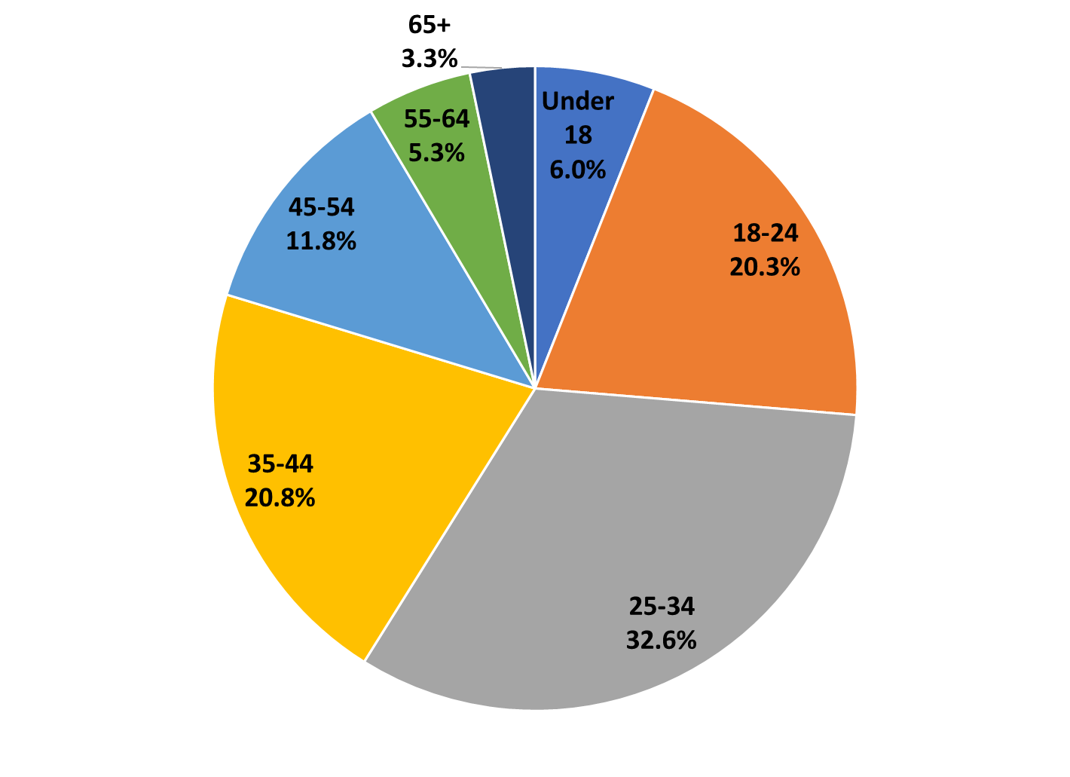

* 6.0% were under the age of 18
* 20.3% were between 18- 24 years old
* 32.6% were between 25-34 years old
* 20.8% were between 35-44 years old
* 11.8% were between 45-54 years old
* 5.3% were between 55- 64 years old
* 3.3% were over the age of 65

Of those who answered, 40.4% of the population were residents of the United Kingdom, 41.4%% of the United States, and 18.3% otherwise international (59.7% total international inc. United States). 46.7% of the sample population reported playing video games daily. 36.9% of the population reported playing less frequently, including weekly (21.2%), monthly (6.9%) or yearly (8.9%). 11.2% of the sample used to play video games but no longer do; 5.2% reported not playing video games at all. The sample was heavily skewed towards young adults, particularly at higher gaming frequencies. For example, 45.8% of under 18s in the sample reported playing daily for more than 2 hours. In contrast, only 12.8% and 14.8% of 45-54 and 55-64 groups respectively, reported playing video games at the same frequency (see Figure 2 below).

**Figure 2:** “How often do you play video games?” by age group.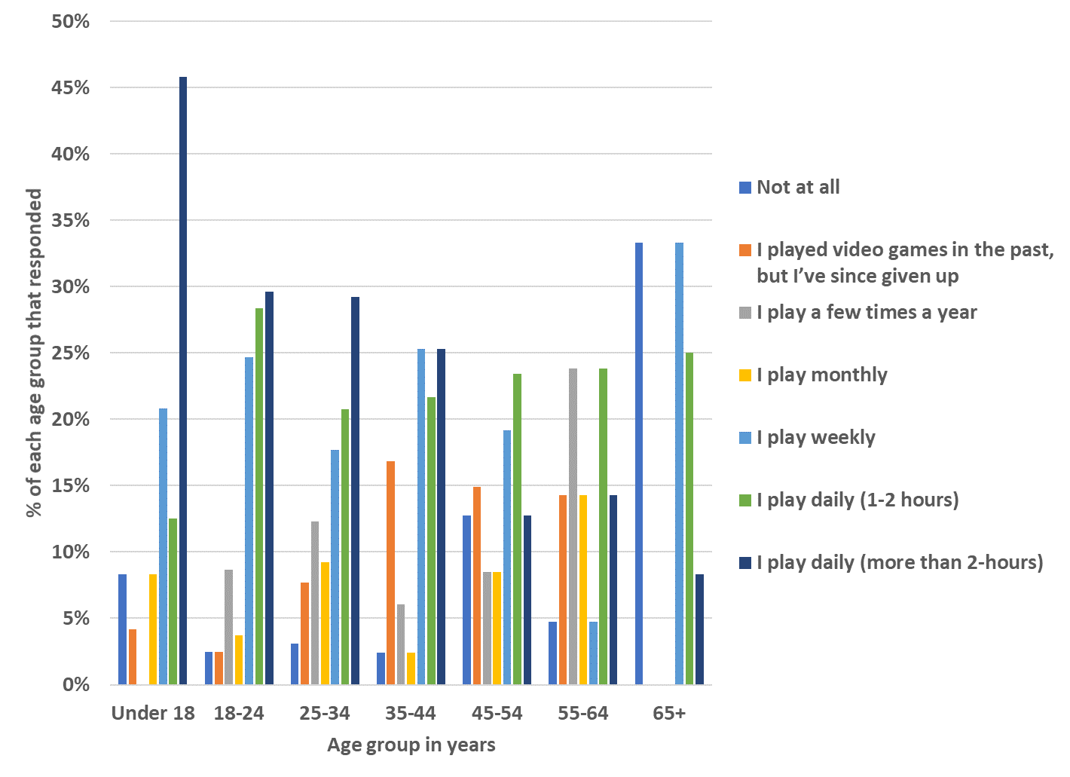

* Under 18: 45.8% play daily (more than 2 hours), 12.5% play daily (1-2 hours), 20.8% play weekly, 8.3% play monthly, none reported playing a few times a year, 4.2% report having played in the past but no longer playing, 8.3% do not play at all.
* 18-24: 29.6% play daily (more than 2 hours), 28.4% play daily (1-2 hours), 24.7% play weekly, 3.7% play monthly, 8.6% play yearly, 2.5% used to but no longer play video games, 2.5% do not play video games at all. 2.5% do not play at all.
* 25-34: 29.2% play daily (more than 2 hours), 20.8% play daily (1-2 hours), 17.7% play weekly, 9.2% play monthly, 12.3% play yearly, 7.7% used to but no longer play video games, 3.1% do not play at all.
* 35-44: 25.3% play daily (more than 2 hours), 21.7% play daily (1-2 hours), 25.3% play weekly, 2.4% play monthly, 6.0% play yearly, 16.9% used to but no longer play video games, 16.9% used to but no longer play video games, 2.4% do not play at all.
* 45-54: only 12.8% play daily (more than 2 hours), 23.4% play daily (1-2 hours), 19.1% play weekly, 8.5% play monthly, 8.5% play yearly, 14.9% used to but no longer play video games, 12.8% do not play at all.
* 55-64: 14.3% play daily (more than 2 hours), 23.8% play daily (1-2 hours), 4.8% play weekly, 14.3% play monthly, 23.8% play yearly, 14.3% used to but no longer play video games, 4.8% do not play at all.
* 65 and older: 8.3% play daily (more than 2 hours), 25.0% play daily (1-2 hours), 33.3% play weekly, 0% play monthly or yearly, 0% used to but no longer play video games, 33.3% do not play at all.

For analysis purposes, gaming frequency is condensed into 4 total groups; non-gamers (those who have never played video games), ex-gamers (those who have played video games but no longer do), light gamers (those who play video games, from a few times a year to weekly) and heavy gamers (those who play daily).

25% of the sample population were sighted or had vision that is corrected with glasses or contacts. 75% of the sample were BPS (67.8% registered as blind or partially sighted, 7.2% have a visual impairment but are unregistered or are unsure if they are registered). In addition to looking at whether participants had vision impairments or not, respondents who were BPS were further sub-grouped into vision impairment severity. Severity level was assessed by dividing people into groups based on the degree to which their vision impairment impacts their ability to play games. Gamers and ex-gamers who were BPS reported to what extent their sight condition impacted their ability to play video games (“not at all,” “to some extent, but I can get by”, “significantly, but I persevere”, “to the extent that I do not/rarely play”). These responses correspond to low, medium, and high severity classifications. For non-gamers with vision impairments or individuals who did not respond to the impact question, the “impairment severity” assignment was based on reported BPS registration status. Participants who reported being registered blind/severely vision impaired were assigned to the high severity impairment group, while those who were registered as partially sighted/vision impaired were assigned to the medium severity impairment group. BPS non-gamers who reported that they were unregistered or were unsure whether they were registered were assigned to the low severity impairment group. Reported analyses examine how responses differ across levels of these variables and their interactions.

The majority of participants with vision impairments were classified as having high severity vision impairment (77.9%). Medium and low severity vision impairment groups made up 18.7% and 2.6% of the BPS sample respectively. 55-64-year-olds were the most likely age group to be classed as having high severity vision impairment (76.2%), whereas, under 18-year-olds were the most likely group to be classed as having medium severity vision impairment (29.2%). As the graph below shows, the sample was skewed towards participants with high severity vision impairment across all age groups (see figure 3).

**Figure 3:** Severity of vision impairment by age group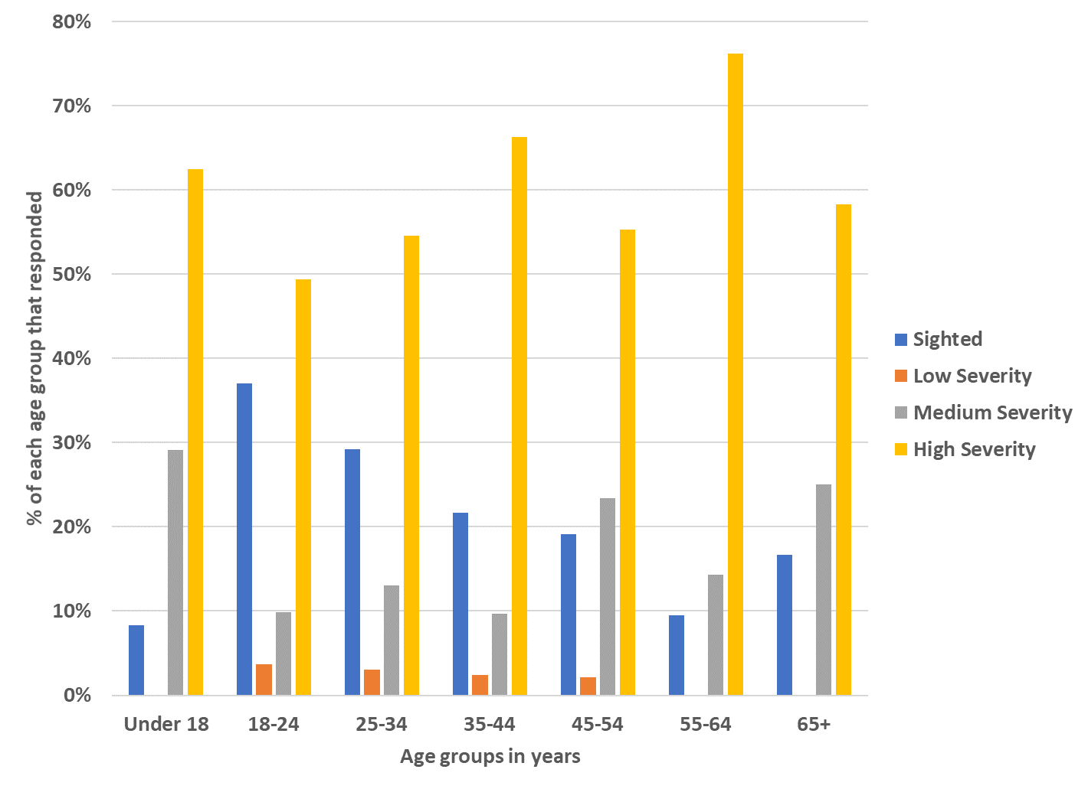

* Under 18: 62.5% were designated as high severity, 29.2% as medium severity, and 8.3% as sighted. No participants under 18 were designated low severity.
* 18-24: 49.4% are high severity, 9.9% are medium severity, 3.7% are low severity, and 37.0% are sighted.
* 25-34: 54.6% are high severity, 13.1% are medium severity, 3.1% are low severity, and 29.2% are sighted.
* 35-44: 66.3% are high severity, 9.6% are medium severity, 2.4% are low severity, and 21.7% are sighted.
* 45-54: 55.3% are high severity, 23.4% are medium severity, 2.1% are low severity, and 19.1% are sighted.
* 55-64: 76.2% are high severity, 14.3% are medium severity, and 9.5% are sighted. No participants aged 55-64 were designated low severity.
* 55-64: 58.3% are high severity, 25.0% are medium severity, and 16.7% are sighted. No participants aged 65+ were designated low severity.

For analysis purposes, based on gaming frequency (non-gamer, ex-gamer, light gamer, heavy gamer) and vision impairment severity (sighted, low severity, medium severity, high severity) participants were assigned to one of 16 possible groups. Where there were low participant numbers or unpopulated groups, these were not included in some analyses.

As shown below in Figure 4, the sample included a high number of participants with high severity vision impairment. This is especially true among light and heavy gamers. Low numbers of non-gamer and ex-gamer with medium and low severity of vision impairment, as well as sighted participants mean that these groups are not represented in the remainder of this chapter.

**Figure 4:** The sample population cut by gaming frequency and impact of vision impairment

**(For presentation purposes, groups with counts smaller than 10 have not been displayed)**

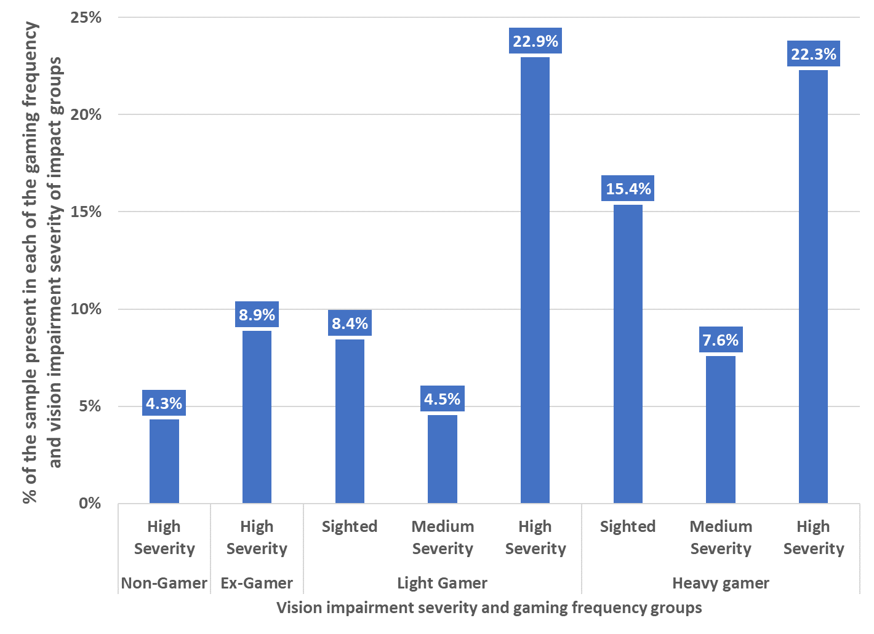

* Non-gamers: high severity: 4.3%
* Ex-gamers: high severity: 8.9%
* Light gamers: sighted: 8.4%, medium severity: 4.5%, high severity: 22.9%
* Heavy gamers: sighted: 15.4%, medium severity: 7.6%, high severity: 22.3%

For some analyses, participants with vision impairments were further differentiated by the types of accessibility features they use, including visual, audio, and touch/haptic features. Participants selected which of the following features they used: Screen Readers, screen magnifiers or CCTV, large text, invert colours or change colour scheme, haptic devices, braille notetaker or braille display, or other. This distinction of accessibility feature groups aims to assess the variety of accessibility features used and determine if the type of feature used is related to other variables of interest, such as whether this accessibility feature is perceived as needed in the future.

## 1.4 Results

### 1.4.1 Motivation and barriers to playing video games

Before identifying potential solutions to improve accessibility of video games, it is important to understand what motivates gamers with vision impairments to play and what barriers they face.

There were a variety of drivers listed by gamers of all sight levels when asked what motivates them to play. By far the most popular motivation given was “fun” (80.9%), followed by “relaxation” (71.1%) and “challenge” (65.1%). Gamers who are BPS were especially likely to select “challenge” as a motivation to play (69.3%) compared to the sample as a whole. This rises to (80%) when looking specifically at heavy gamers with medium severity vision impairment (see figure 5 a & b for more information).

**Figures 5 a & b**: Motivations for playing video games: “I play video games for the…”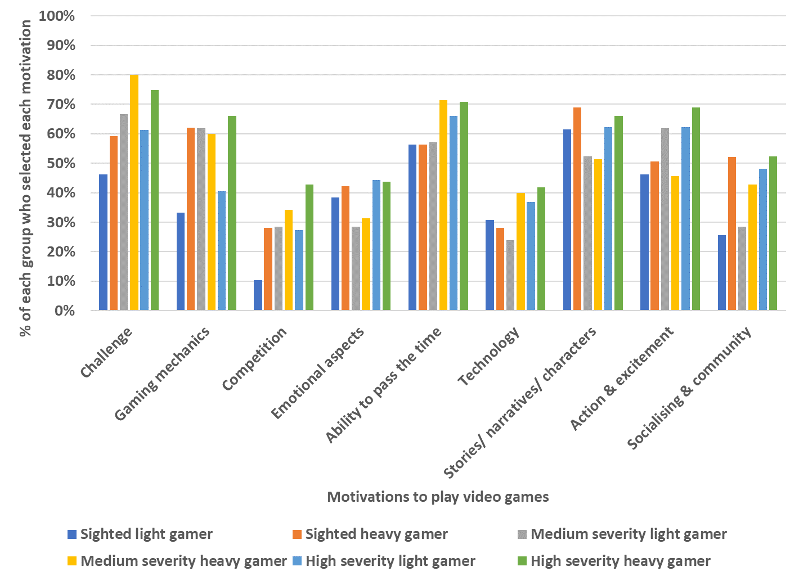

* Challenge: 46.2% of sighted light gamers, 59.2% of sighted heavy gamers, 66.7% of medium severity light gamers, 80% of medium severity heavy gamers, 61.3% of high severity light gamers and 74.8% of heavy gamers selected this motivation
* Gaming mechanics: 33.3% of sighted light gamers, 62% of sighted heavy gamers, 61.9% of medium severity light gamers, 60% of medium severity heavy gamers, 40.6% of high severity light gamers and 66% of high severity heavy gamers selected this motivation.
* Competition: 10.3% of sighted light gamers, 28.2% of sighted heavy gamers, 28.6% of medium severity light gamers, 34.3% of medium severity heavy gamers, 27.4% of high severity light gamers and 42.7% of high severity heavy gamers selected this motivation.
* Emotional aspects: 38.5% of sighted light gamers, 42.3% of sighted heavy gamers, 28.6% of medium severity light gamers, 31.4% of medium severity heavy gamers, 44.3% of high severity light gamers and 43.7% of high severity heavy gamers selected this motivation.
* Ability to pass the time: 56.4% of sighted light gamers, 56.3% of sighted heavy gamers, 57.1% of medium severity light gamers, 71.4% of medium severity heavy gamers, 66% of high severity light gamers and 70.9% of high severity heavy gamers selected this motivation.
* Technology: 30.8% of sighted light gamers, 28.2% of sighted heavy gamers, 23.8% of medium severity light gamers, 40% of medium severity heavy gamers, 36.8% of high severity light gamers and 41.7% of high severity heavy gamers selected this motivation.
* Stories/ narratives/ characters: 61.5% of sighted light gamers, 69% of sighted heavy gamers, 52.4% of medium severity light gamers, 51.4% of medium severity heavy gamers, 62.3% of high severity light gamers and 66% of high severity heavy gamers selected this motivation.
* Action & excitement: 46.2% of sighted light gamers, 50.7% of sighted heavy gamers, 61.9% of medium severity light gamers, 45.7% of medium severity heavy gamers, 62.3% of high severity light gamers and 68.9% of high severity heavy gamers selected this motivation.
* Socialising & community: 25.6% of sighted light gamers, 52.1% of sighted heavy gamers, 28.6% of medium severity light gamers, 42.9% of medium severity heavy gamers, 48.1% of high severity light gamers and 52.4% of high severity heavy gamers selected this motivation.

**Figures 5 a & b**: Motivations for playing video games: “I play video games for the…”

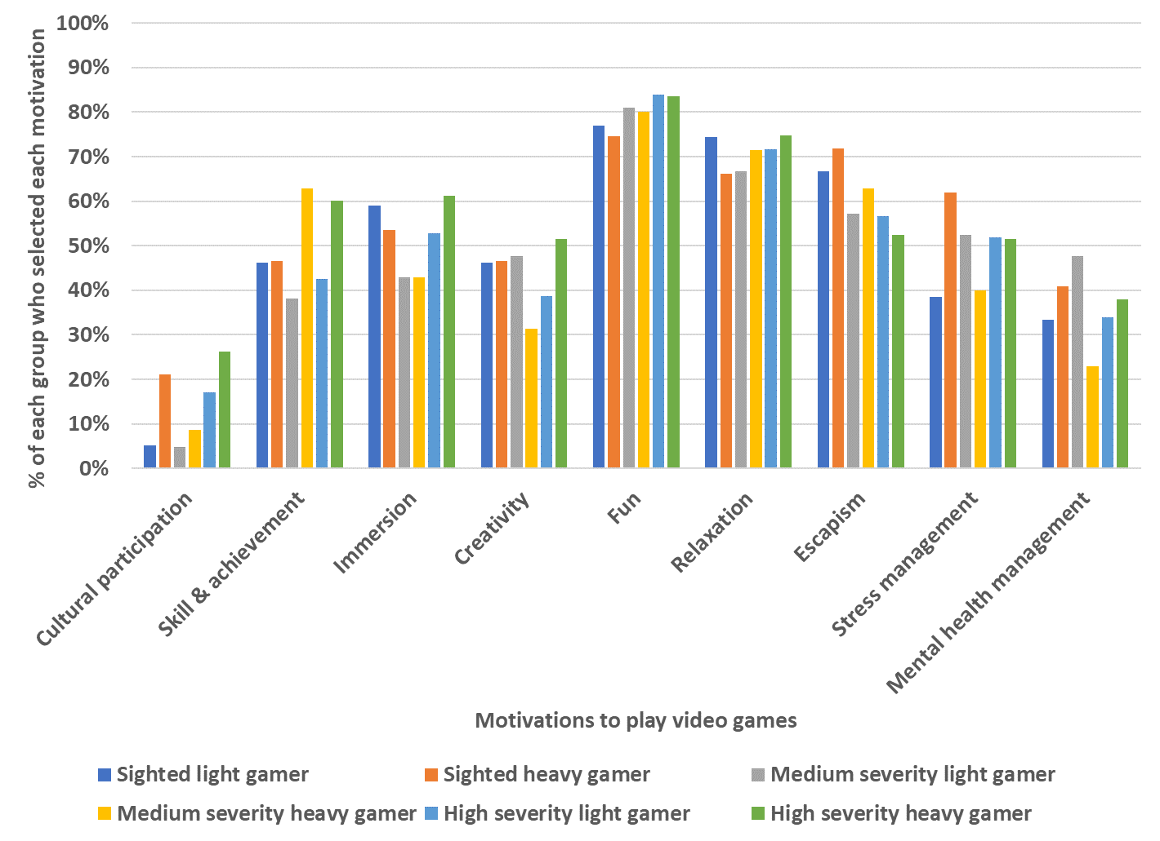

* Cultural participation: 5.1% of sighted light gamers, 21.1% of sighted heavy gamers, 4.8% of medium severity light gamers, 8.6% of medium severity heavy gamers, 17% of high severity light gamers and 26.2% of high severity heavy gamers selected this motivation.
* Skill & achievement: 46.2% of sighted light gamers, 46.5% of sighted heavy gamers, 38.1% of medium severity light gamers, 62.9% of medium severity heavy gamers, 42.5% of high severity light gamers and 60.2% of high severity heavy gamers selected this motivation.
* Immersion: 59% of sighted light gamers, 53.5% of sighted heavy gamers, 42.9% of medium severity light gamers, 42.9% of medium severity heavy gamers, 52.8% of high severity light gamers and 61.2% of high severity heavy gamers selected this motivation.
* Creativity: 46.2% of sighted light gamers, 46.5% of sighted heavy gamers, 47.6% of medium severity light gamers, 31.4% of medium severity heavy gamers, 38.7% of high severity light gamers and 51.5% of high severity heavy gamers selected this motivation.
* Fun: 76.9% of sighted light gamers, 74.6% of sighted heavy gamers, 81% of medium severity light gamers, 80% of medium severity heavy gamers, 84% of high severity light gamers and 83.5% of high severity heavy gamers selected this motivation.
* Relaxation: 74.4% of sighted light gamers, 66.2% of sighted heavy gamers, 66.7% of medium severity light gamers, 71.4% of medium severity heavy gamers, 71.7% of high severity light gamers and 74.8% of high severity heavy gamers selected this motivation.
* Escapism: 66.7% of sighted light gamers, 71.8% of sighted heavy gamers, 57.1% of medium severity light gamers, 62.9% of medium severity heavy gamers, 56.6% of high severity light gamers and 52.4% of high severity heavy gamers selected this motivation.
* Stress management: 38.5% of sighted light gamers, 62% of sighted heavy gamers, 52.4% of medium severity light gamers, 40% of medium severity heavy gamers, 51.9% of high severity light gamers and 51.5% of high severity heavy gamers selected this motivation.
* Mental health management: 33.3% of sighted light gamers, 40.8% of sighted heavy gamers, 47.6% of medium severity light gamers, 22.9% of medium severity heavy gamers, 34% of high severity light gamers and 37.9% of high severity heavy gamers selected this motivation.

These results show the importance of challenge and achievement for the BPS population, especially amongst those who play more frequently. It could be that the added obstacle of vision impairment accentuates the difficulty level of video games, making challenge and achievement more important to the gaming experience of those who are BPS. It is important for the games industry to recognise that accessibility improvements must improve access rather than diminishing the requirement for challenge.

Although those who are BPS state they are motivated to play games, there was recognition that improvements to accessibility would aid their gaming experience and affect their motivation to play. A majority of the sample who are BPS reported that they would play video games more if they were made accessible, including those identified as ex-gamers and non-gamers. 92.2% of the full sample of participants with vision impairments said they “strongly agree” or “agree” that they would play if games were made more accessible; among non-gamers this shrinks to 83.3%, but for ex-gamers, this increases to 100%.

When playing video games that are deemed accessible, players who are sighted and those who are BPS report high levels of relaxation, understanding and comprehension. Across all gaming frequency groups, those with a medium level of vision impairment are most likely to report feeling relaxed while playing accessible games, while users with high severity vision impairment are most likely to report comprehension and ease of gameplay. Understandably gameplay is easier, more enjoyable, and relaxing for users with vision impairments when games are accessible.

These results suggest a strong appetite for gaming and an underserved market in users with vision impairments. By improving accessibility, the games industry has much to gain. For current gamers, accessibility leads to a better gameplay experience and improved user satisfaction. Therein lies potential for the games industry to impress and value a currently motivated market. For ex-gamers who currently feel locked out of an activity which they had previously shown motivation for, there is the potential to re-engage these users.

Whilst there is clearly an appetite among BPS individuals to play games, an understanding of the dominant barriers to access would help guide the industry's response and development of the most appropriate solutions. A majority of the sample with vision impairments reported that their ability to play video games was significantly impacted by their sight condition (76.3%). This indicates the presence of significant barriers and a lack of consideration for accessibility. A clear understanding of the barriers that people with visual impairments face will be critical to developing future accessibility features.

For ex-gamers and non-gamers who are BPS, poor accessibility of games and the detrimental impact of their vision impairment to gameplay are the dominant barriers to gaming. When asked why they do not play video games, these participants consistently selected “video games do not have enough accessibility features”, “my vision impairment puts me off playing”, or “my vision impairment prevents me from playing” (see Figure 6). Ex-gamers with vision impairments were especially likely to cite accessibility issues as a barrier to gameplay, suggesting they have tried to play video games and failed to find adaptations that allowed them to adequately enjoy play.

**Figure 6**: “Considering why you do not play video games, please select the following options that you agree with (select all that apply)”

(Answers from non-gamers and ex-gamers from the medium and high severity vision impairment groups).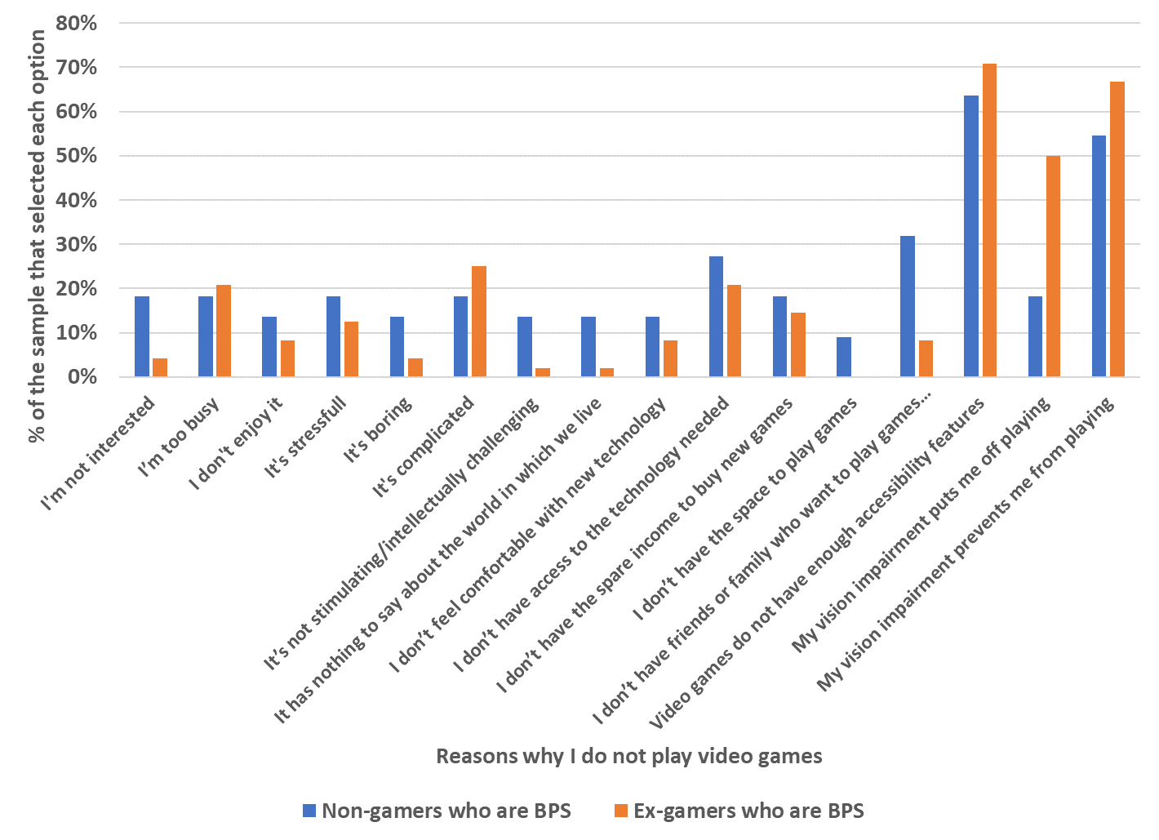

* I’m not interested: 18.2% of BPS non-gamers, 4.2% of BPS ex-gamers.
* I’m too busy: 18.2% of BPS non-gamers, 20.8% of BPS ex-gamers.
* I don’t enjoy it: 13.6% of BPS non-gamers, 8.3% of BPS ex-gamers.
* It’s stressful: 18.2% of BPS non-gamers, 12.5% of BPS ex-gamers.
* It’s boring: 13.6% of BPS non-gamers, 4.2% of BPS ex-gamers.
* It’s complicated: 18.2% of BPS non-gamers, 25.0% of BPS ex-gamers.
* It’s not stimulating/intellectually challenging: 13.6% of BPS non-gamers, 2.1% of BPS ex-gamers.
* It has nothing to say about the world in which we live: 13.6% of BPS non-gamers, 2.1% of BPS ex-gamers.
* I don’t feel comfortable with new technology: 13.6% of BPS non-gamers, 8.3% of BPS ex-gamers.
* I don’t have access to the technology needed: 27.3% of BPS non-gamers, 20.8% of BPS ex-gamers.
* I don’t have the spare income to buy new games: 18.2% of BPS non-gamers, 14.6% of BPS ex-gamers.
* I don’t have the space to play games: 9.1% of BPS non-gamers, 0% of BPS ex-gamers.
* I don’t have friends or family who want to play games with me: 31.8% of BPS non-gamers, 8.3% of BPS ex-gamers.
* Video games do not have enough accessibility features: 63.6% of BPS non-gamers, 70.8% of BPS ex-gamers.
* My vision impairment puts me off playing: 18.2% of BPS non-gamers, 50% of BPS ex-gamers.
* My vision impairment prevents me from playing: 54.5% of BPS non-gamers, 66.7% of BPS ex-gamers.

Accessibility issues dominate the barriers to gameplay for BPS individuals. However, accessibility tends to vary depending on the gaming genre (Figure 7). Whilst gamers and ex-gamers who are BPS have experienced accessibility issues in a range of video game genres (puzzle and strategy games, racing games, first person shooter games, and massive multiplayer online (MMO) games) the most commonly selected genres that participants experienced accessibility issues with were racing games (48.5%) and sports games (49.4%). Among heavy gamers with high severity impairments, shooter games (77.3%) and MMO games (73.7%) were most often associated with accessibility issues.

It’s possible that accessibility issues in these genres may have pushed gamers who are BPS away from gameplay altogether. As mentioned, a high percentage of ex-gamers with vision impairments reported that a reason they no longer play video games is due to accessibility related issues. Ex-gamers with high vision impairment reported experiencing accessibility issues with racing (71.4%) and sports games (66.7%) and simulation games (68.8%). This suggests that accessibility obstacles are most prevalent in these genres and that they particularly affect gamers with a preference for these types of games. It could be that for BPS individuals preferring racing, sports, and simulation games the barriers to accessing video games are higher than for people preferring other genres.

It is true that some game genres may inherently be more accessible for people who are BPS. Audio games and Multi-User Dimension (MUD) games were selected least often by the overall BPS sample for accessibility issues being experienced (8.5% and 17.9% respectively). These genres, by their nature, are more accessible to those with vision impairment as MUD games tend to be text based and are therefore compatible with accessibility tools (e.g. screen readers, text magnifiers etc) and audio games are heavily based on sound rather than visuals. Interestingly, light gamers with medium severity vision impairment were most likely to report that they had experienced accessibility issues in audio games (29.6%). This shows that this genre still may have some work to do to become more accessible.

**Figures 7a & 7b:** Frequency of accessibility issues across gaming genres.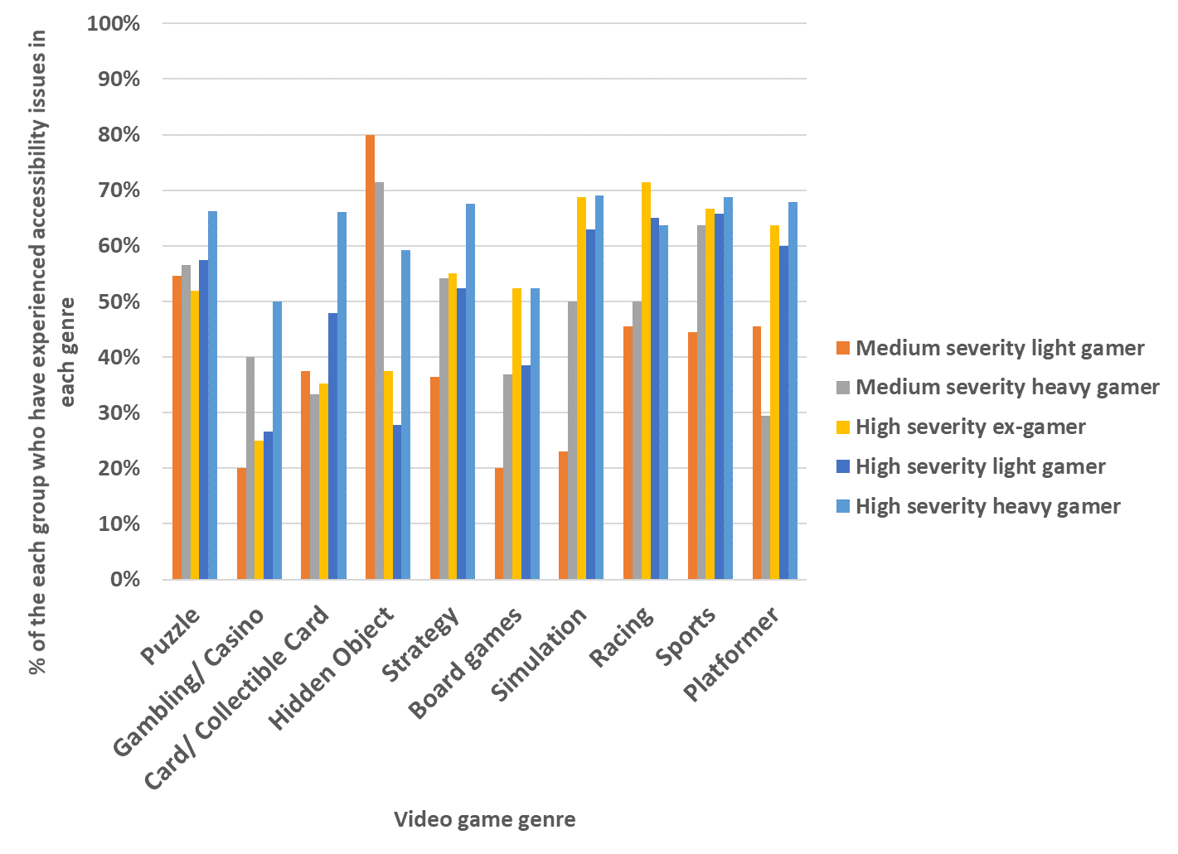

* Puzzle games: 54.5% of medium severity light gamers, 56.5% of medium severity heavy gamers, 51.9% of high severity ex-gamers, 57.4% of high severity light gamers, and 66.2% of high severity heavy gamers experienced accessibility issues with puzzle games.
* Gambling/Casino games: 20% of medium severity light gamers, 40% of medium severity heavy gamers, 25% of high severity ex-gamers, 26.7% of high severity light gamers, and 50% of high severity heavy gamers experienced accessibility issues.
* Card/Collectible Card games: 37.5% of medium severity light gamers, 33.3% of medium severity heavy gamers, 35.3% of high severity ex-gamers, 47.9% of high severity light gamers, and 66% of high severity heavy gamers experienced accessibility issues.
* Hidden Object games: 80% of medium severity light gamers, 71.4% of medium severity heavy gamers, 37.5% of high severity ex-gamers, 27.8% of high severity light gamers, and 59.3% of high severity heavy gamers experienced accessibility issues.
* Strategy games: 36.4% of medium severity light gamers, 54.2% of medium severity heavy gamers, 55.0% of high severity ex-gamers, 52.4% of high severity light gamers, and 67.5% of high severity heavy gamers experienced accessibility issues.
* Board games: 20.0% of medium severity light gamers, 36.8% of medium severity heavy gamers, 52.4% of high severity ex-gamers, 38.5% of high severity light gamers, and 52.4% of high severity heavy gamers experienced accessibility issues.
* Simulation games: 23.1% of medium severity light gamers, 50% of medium severity heavy gamers, 68.8% of high severity ex-gamers, 63% of high severity light gamers, and 69% of high severity heavy gamers experienced accessibility issues.
* Racing games: 45.5% of medium severity light gamers, 50% of medium severity heavy gamers, 71.4% of high severity ex-gamers, 65% of high severity light gamers, and 63.6% of high severity heavy gamers experienced accessibility issues.
* Sports games: 44.4% of medium severity light gamers, 63.6% of medium severity heavy gamers, 66.7% of high severity ex-gamers, 65.7% of high severity light gamers, and 68.8% of high severity heavy gamers experienced accessibility issues.
* Platformer games: 45.5% of medium severity light gamers, 29.4% of medium severity heavy gamers, 63.6% of high severity ex-gamers, 60% of high severity light gamers, and 67.8% of high severity heavy gamers experienced accessibility issues.

**Figures 7a & 7b:** Frequency of accessibility issues across gaming genres.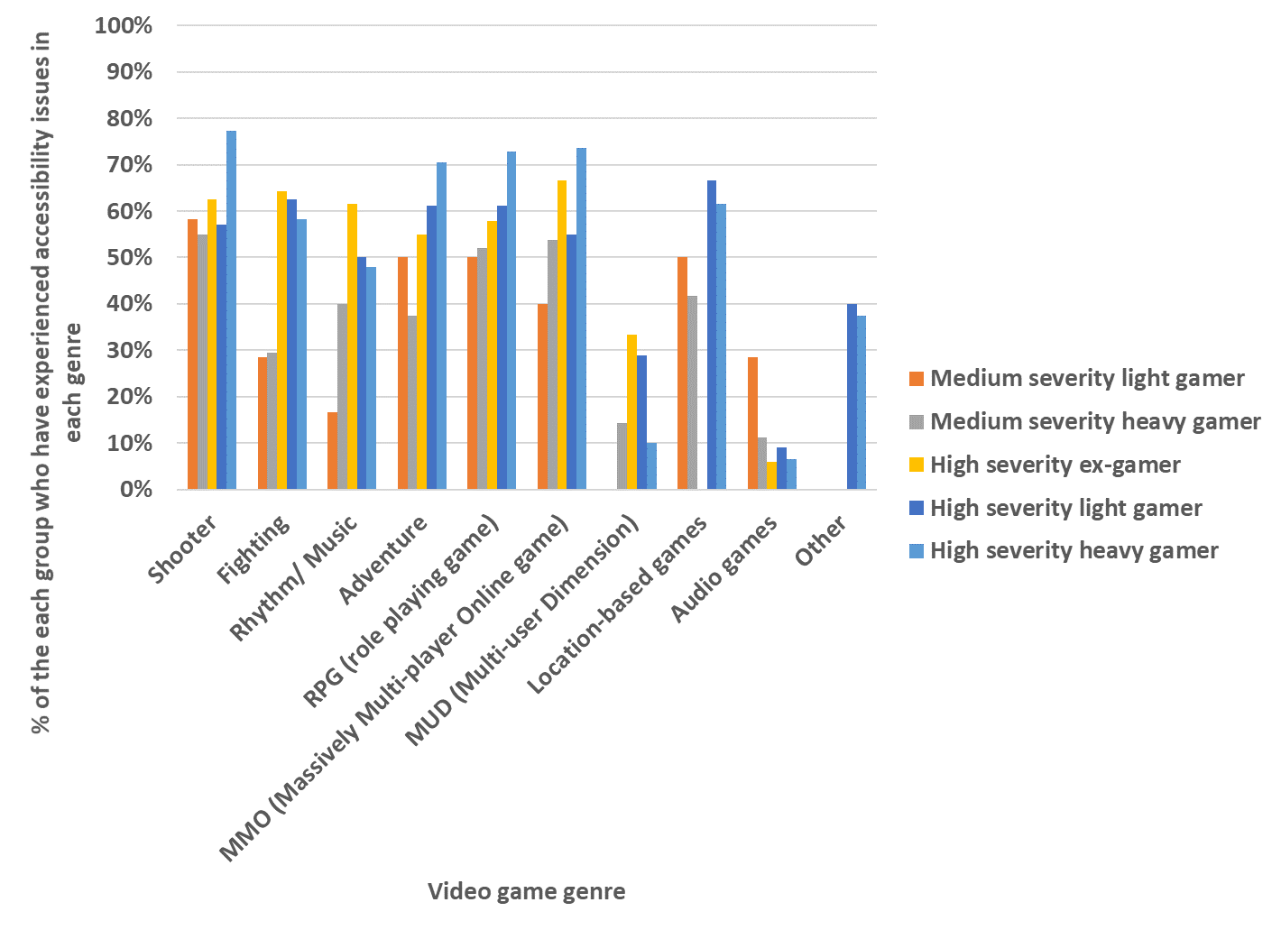

* Shooter games: 58.3% of medium severity light gamers, 55% of medium severity heavy gamers, 62.5% of high severity ex-gamers, 57.1% of high severity light gamers, and 77.3% of high severity heavy gamers experienced accessibility issues with puzzle games.
* Fighting games: 28.6% of medium severity light gamers, 29.4% of medium severity heavy gamers, 64.3% of high severity ex-gamers, 62.5% of high severity light gamers, and 58.3% of high severity heavy gamers experienced accessibility issues.
* Rhythm/Music games: 16.7% of medium severity light gamers, 40% of medium severity heavy gamers, 61.5% of high severity ex-gamers, 50% of high severity light gamers, and 47.9% of high severity heavy gamers experienced accessibility issues.
* Adventure games: 50% of medium severity light gamers, 37.5% of medium severity heavy gamers, 55% of high severity ex-gamers, 61.2% of high severity light gamers, and 70.4% of high severity heavy gamers experienced accessibility issues.
* RPG (role playing games): 50% of medium severity light gamers, 52% of medium severity heavy gamers, 57.9% of high severity ex-gamers, 61.2% of high severity light gamers, and 72.8% of high severity heavy gamers experienced accessibility issues.
* MMO (massively multi-player online) games: 40% of medium severity light gamers, 53.8% of medium severity heavy gamers, 66.7% of high severity ex-gamers, 54.8% of high severity light gamers, and 73.7% of high severity heavy gamers experienced accessibility issues.
* MUD (multi-user dimension) games: 0% of medium severity light gamers, 14.3% of medium severity heavy gamers, 33.3% of high severity ex-gamers, 28.9% of high severity light gamers, and 10% of high severity heavy gamers experienced accessibility issues.
* Location-based games: 50% of medium severity light gamers, 41.7% of medium severity heavy gamers, 0% of high severity ex-gamers, 66.7% of high severity light gamers, and 61.5% of high severity heavy gamers experienced accessibility issues.
* Audio games: 28.6% of medium severity light gamers, 11.1% of medium severity heavy gamers, 5.9% of high severity ex-gamers, 9% of high severity light gamers, and 6.5% of high severity heavy gamers experienced accessibility issues.
* Other game types: 0% of medium severity light gamers, 0% of medium severity heavy gamers, 0% of high severity ex-gamers, 40% of high severity light gamers, and 37.5% of high severity heavy gamers experienced accessibility issues.

Regardless of genre there are clearly improvements to be made across the board to ensure equitable access to the range of games that individuals who are BPS show motivation to engage with. The data collected shows that all gamers who are BPS have experienced significant barriers to playing video games. Ex-gamers and non-gamers with vision impairments also cite inaccessibility as a primary reason they do not play video games. Those who do play video games do so in spite of significant accessibility issues across all types of game. These results serve as confirmation of the inaccessibility of video games for those with vision impairments and the importance of better understanding the specific accessibility needs of gamers who are BPS.

### 1.4.2. User perspectives on accessibility

Whilst there is clearly an underserved market of gamers who are BPS, it is important to evaluate users’ opinions regarding the perceived inaccessibility of video games and identify any impact this might have on how the games industry addresses inaccessibility challenges. For example, here we explore how receptive this market is to the games industry and whether there are differences in perception between gamers who are sighted and those who are BPS. The data presented here begins to demonstrate the detrimental impact of not considering accessibility for all users.

The data collected supports the premise that individuals’ specific experiences with video games shapes their perspective on accessibility. Ex-gamers and non-gamers are the most likely of all gaming groups with vision impairments to see video games as inaccessible to users who are BPS (48.7% and 41.2% respectively). These non-gaming participants perceive video games as less accessible than those who game (16.8% of light gamers and 12.8% of heavy gamers view video games as inaccessible). Furthermore, ex-gamers and non-gamers with visual impairments are more likely to report that video games are “not at all accessible”, rather than being “inaccessible to some extent”, again supporting the view that accessibility issues lead to disengagement from gaming. Heavy and light gamers with visual impairments and sighted gamers are more likely to think that video games are accessible “to some extent”, which suggests that these individuals have found some ways to adapt gameplay to their needs.

Interestingly, less than 10% of the full sample believes video games are “fairly” or “very accessible”. So, while some highly motivated gamers have continued gaming despite accessibility barriers, there is much room for improved perception of accessibility. The perspective of sighted gamers is similar to that of gamers who are BPS, indicating that sighted users are aware of the challenges people with vision impairments may face while engaging with video games.

This negative perception of accessibility of video games extends to the companies that develop inaccessible games. When asked how they feel about companies that do not consider accessibility, the average response is negative (over 95% of the full sample gave a negative response). Results indicate that those with higher levels of vision impairment hold significantly stronger negative opinions of gaming companies who do not consider accessibility. Ex-gamers and non-gamers with high severity vision impairment consistently hold negative views; 75.8% and 73.3% of these groups respectively, reported they feel “very negative” about companies that do not consider accessibility. This negative view could contribute to why they no longer or do not play video games. Sighted gamers were more likely to report a “somewhat negative” response, as opposed to the group with vision impairments’ “very negative” opinion. These results, coupled with a demonstrated desire of people with vision impairments to play video games, further suggests an underserved consumer group and strong impact of personal circumstance on opinions surrounding accessibility. These results also highlight the reputational effect that video game companies may face when implementing (or neglecting) accessibility features in the games they produce.

### 1.4.3 Platform preference, desired access features and adaptations

As highlighted in the industry research, the games industry must prioritise which accessibility features will serve the greatest needs. To understand where there is most potential for improvements in accessibility features, all gamers and ex-gamers were asked to select the video gaming platforms they had experience with and rank their top 3 preferred platforms. Gaining this perspective on platform preference allows for providing nuanced recommendations to industry regarding market potential for development of specific accessibility features.

PCs are the most common gaming platform experienced by the sample as a whole (78.1%). Additionally, gamers and ex-gamers who are BPS had a lot of experience using IOS (66.8%) and web browsers (54.2%), while for sighted gamers and ex-gamers Android (51.8%) and IOS (50.9%) platforms were the next most common.

Overall, this exploration of platform preference highlights that computers and mobile devices were by far the most common gaming platforms for gamers and ex-gamers with vision impairments and those who are sighted. This suggests that game developers producing games for PC and mobile already have a significant market of gamers who are BPS and therefore, familiar with their controls and user-experience.

A platform with arguably less market readiness (among individuals who are BPS) but greater need for improvement for accessibility development is consoles. Gamers and ex-gamers with vision impairments had dramatically less experience with consoles than sighted gamers and ex-gamers. Only 57.5% of gamers and ex-gamers with vision impairments had experience with console games, compared to 71.9% of sighted gamers and ex-gamers. When asked why different platforms were preferred, “worked well for them” and that they “were accessible” were the most common reasons (these reasons were chosen by the sample 72.8% and 76.8% of the time on average) (gaming frequency and vision impairment severity breakdowns can be viewed in figure 8). This implies that since consoles are accessed less by those who are BPS they may be deemed less accessible than PCs and mobile devices. As the findings on motivation to game show, there is desire among those who are BPS to game. Therefore, although console game developers may need to attract users to their platform and change usage habits, there could be much to gain in doing so both reputationally and economically.

**Figure 8:** The average frequency in which the sample selected each reason for their video game platform preference.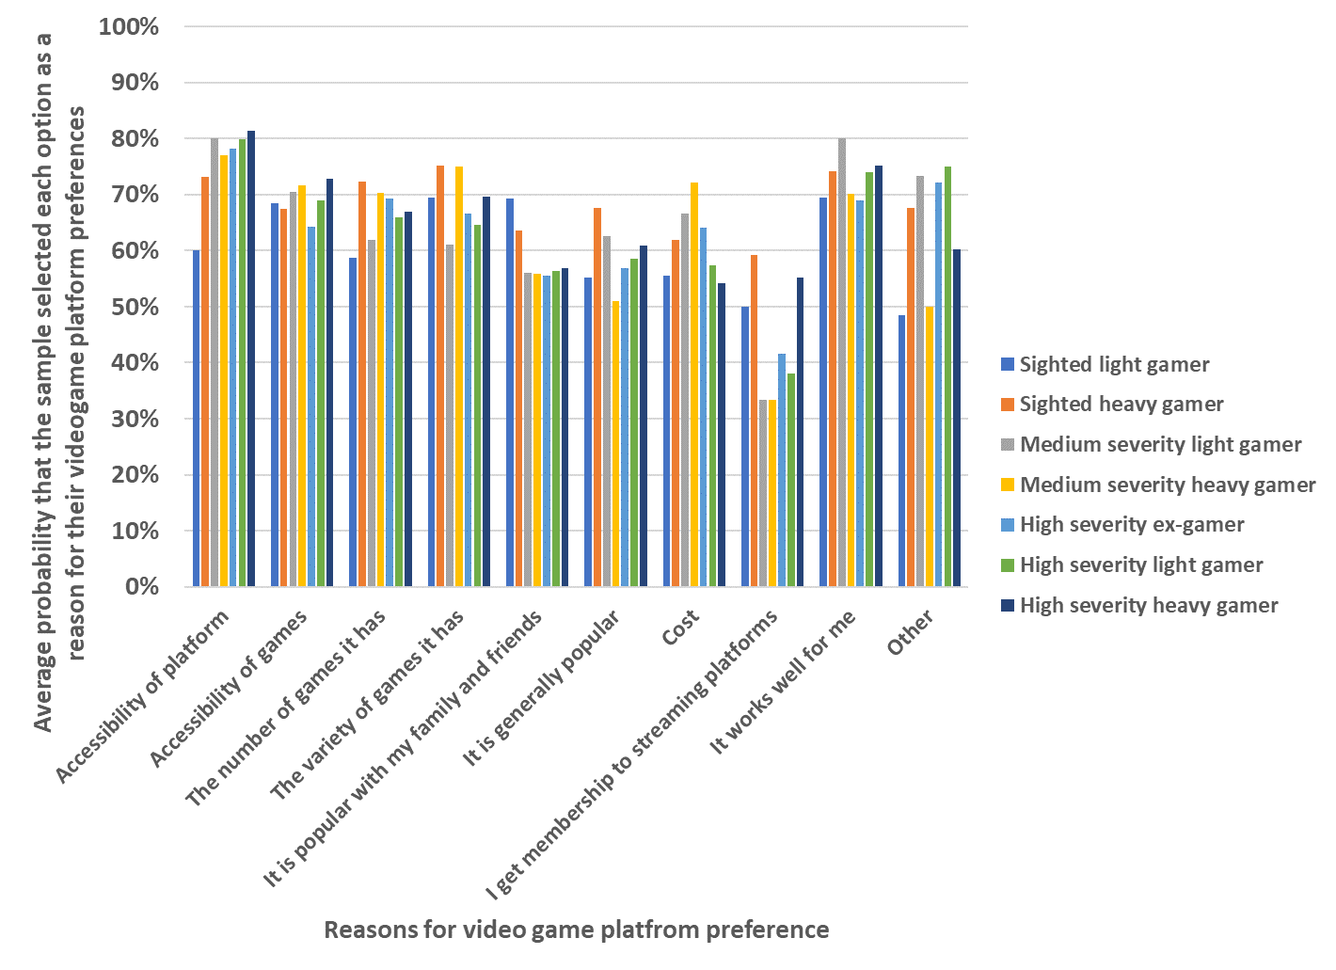

* Accessibility of platform: 60% of sighted light gamers, 73.1% of sighted heavy gamers, 80% of medium severity light gamers, 77.1% of medium severity heavy gamers, 78.2% of high severity ex-gamers, 79.9% of high severity light gamers and 81.3% of high severity heavy gamers selected this motivation.
* Accessibility of games: 68.5% of sighted light gamers, 67.5% of sighted heavy gamers, 70.5% of medium severity light gamers, 71.7% of medium severity heavy gamers, 64.3% of high severity ex-gamers, 69% of high severity light gamers and 72.9% of high severity heavy gamers selected this motivation.
* The number of games it has: 58.7% of sighted light gamers, 72.3% of sighted heavy gamers, 61.9% of medium severity light gamers, 70.4% of medium severity heavy gamers, 69.2% of high severity ex-gamers, 65.9% of high severity light gamers and 66.9% of high severity heavy gamers selected this motivation.
* The variety of games it has: 69.5% of sighted light gamers, 75.2% of sighted heavy gamers, 61.1% of medium severity light gamers, 75% of medium severity heavy gamers, 66.7% of high severity ex-gamers, 64.7% of high severity light gamers and 69.6% of high severity heavy gamers selected this motivation.
* It is popular with my family and friends: 69.3% of sighted light gamers, 63.6% of sighted heavy gamers, 56.1% of medium severity light gamers, 55.8% of medium severity heavy gamers, 55.6% of high severity ex-gamers, 56.3% of high severity light gamers and 56.9% of high severity heavy gamers selected this motivation.
* It is generally popular: 55.3% of sighted light gamers, 67.6% of sighted heavy gamers, 62.5% of medium severity light gamers, 51% of medium severity heavy gamers, 56.9% of high severity ex-gamers, 58.6% of high severity light gamers and 60.9% of high severity heavy gamers selected this motivation.
* Cost: 55.6% of sighted light gamers, 62% of sighted heavy gamers, 66.7% of medium severity light gamers, 72.2% of medium severity heavy gamers, 64.1% of high severity ex-gamers, 57.3% of high severity light gamers and 54.2% of high severity heavy gamers selected this motivation.
* I get membership to streaming platforms: 50% of sighted light gamers, 59.3% of sighted heavy gamers, 33.3% of medium severity light gamers, 33.3% of medium severity heavy gamers, 41.7% of high severity ex-gamers, 38.1% of high severity light gamers and 55.2% of high severity heavy gamers selected this motivation.
* It works well for me: 69.4% of sighted light gamers, 74.2% of sighted heavy gamers, 80% of medium severity light gamers, 70.1% of medium severity heavy gamers, 68.9% of high severity ex-gamers, 74% of high severity light gamers and 75.2% of high severity heavy gamers selected this motivation.
* Other: 48.5% of sighted light gamers, 67.5% of sighted heavy gamers, 73.3% of medium severity light gamers, 50% of medium severity heavy gamers, 72.2% of high severity ex-gamers, 75% of high severity light gamers and 60.2% of high severity heavy gamers selected this motivation.

Another industry ripe for exploration is that of audio platforms. 38.5% of participants with vision impairments had experience using Amazon Alexa compared to 7% of sighted gamers and ex-gamers.

Interestingly, of those with vision impairments, light gamers were the most likely of the groups to prefer Amazon Alexa (51%), suggesting that it may be better suited as an occasional gaming platform rather than as one used daily. Due to the audio only nature of Alexa, it may lack a lot of other features and capabilities that platforms like PCs, consoles and IOS devices have, meaning it may not yet have captured a frequent gamer market. This highlights much opportunity for growth. Improving accessibility on platforms where there is already a significant user base of those who are BPS is a logical first step to make improvements which could lead to an industry step change overall.

The preference for audio was not just noted when exploring platform preference. This trend continued when participants were asked about which types of accessibility features have most enhanced the experience of gameplay. 70.8% of gamers and ex-gamers who are BPS selected at least one of the following audio features (“Standard audio description”, “Personalised description tracks”, “Spatial audio”, “Audio triggers”, or “Compatibility with screen readers”) as improving their experience. In addition to being the most popular experience-enhancing accessibility features, audio features stand out as the most commonly desired type of accessibility adaptation. 82.5% of all participants with vision impairments identified at least one audio-based feature as one they would like to see in the future. Audio features are consistently desired across all vision impairment severity groups. Audio features are also desired by those for whom audio is not their usual accessibility choice. For example, 81.8% of those who use large text exclusively, still desire audio-based features.

These results indicate that prioritising development and implementation of more audio-based accessibility features would significantly enhance the experience of the largest number of users with vision impairments. The findings on platform preference highlight that improved audio features could enhance experience on PCs and mobile devices.

Furthermore, for Amazon Alexa, exploring the range of audio possibilities such as spatial audio, personalised description tracks and more, could improve this device for a burgeoning market of gamers who are BPS.

Whilst audio is a priority for accessibility feature development it is certainly not the only route for enhancing video games. The findings show that touch-based and haptic features were also frequently selected as being desirable, particularly among those with medium and high vision impairment. This suggests a healthy mix of different sensory accessibility features is likely an effective way to make gaming more accessible to those with vision impairments. Though audio and haptic features stand out (66.2%), visual (51.1%) and instructional (60.3%) features were also desired.

Whilst the focus of this report is to better understand how accessibility can be improved for those who are BPS, we also explored whether accessibility features could enhance sighted gamers’ experience of gameplay. All participants (BPS and sighted) were asked which accessibility features enhance their experience of video games. Users who are BPS most often selected “compatibility with screen readers” (57.9%) and “audio description or integrated narrative descriptions” (51.3%). Nearly half of all sighted users selected “change font size” (42.6%). More specific features relating to audio customisation were also popular with individuals who are BPS and sighted. For example, the option to change audio settings (mono, surround, binaural) was selected by 32.3% of participants who are BPS and 22.6% of sighted participants, and the option for an adaptable sound mix (dialogue, music, sound effects), was selected by 36.9% of participants with vision impairments and 33% of sighted individuals. This suggests that adapting and customising video games to suit personal preference can enhance the experience of any player, whether or not they have a diagnosed vision impairment.

## 1.5 Conclusions and recommendations

This report demonstrates the needs and preferences of those with BPS for improving access to video games as well as highlighting opportunities for the games industry in capturing this underserved market of users.

* The report shows clearly that gamers who are BPS face a number of barriers to video games relating to accessibility issues. Individuals with vision impairment that have stopped gaming cite accessibility issues as a key reason for why they no longer game.
* Despite these obstacles, gamers with vision impairments have a wide variety of motivations to game, as well as experiences with platforms. This group uses a range of features and strategies when gaming and have a strong desire for more (especially audio-based features, e.g. compatibility with screen readers, and audio based integrated narrative descriptions).
* Some features were valued by both sighted and BPS participants alike (e.g. the option to change audio settings and adaptable sound mix), highlighting an easy win for the games industry in making video games more accessible.
* Whilst there is an openness to playing games that have more accessibility features, the perception of the games industry regarding accessibility is broadly negative. This indicates that the industry may need to build trust among BPS individuals and demonstrate willingness to build accessibility into design from the earliest point. As this report demonstrates there are some quick wins that could lead to a step change within the industry and great appreciation among users.

### 1.5.1 Research recommendations

In order to gain a better understanding of user needs and guide the industry toward developing the most robust and viable accessibility features, we recommend further research is needed to:

* Measure the usage and popularity of accessibility features in games of different genres in real-world settings when played by gamers with differing levels of sight loss.
* Understand the economic impact of including more accessibility features. For example, assessing the market size of BPS gamers and their willingness to pay for different games and the potential ROI. This exercise would help to improve industry confidence for including accessibility features in games.
* Understand the different middleware considerations and interdependencies of accessibility within the tech stack.

# Chapter 2: Qualitative study

This chapter reports findings from the one-to-one interviews carried out with 21 people who have experience of playing different types of video games at different levels. People with different sight levels were included as well as people with interest and experience in playing different types of games. The interviews aimed to explore accessibility in relation to gaming, and potential accessibility barriers to playing games.

## 2.1 Methodology

The quantitative study was used to identify people who were interested in participating in detailed one-to-one interviews. Participants were screened and selected to ensure a wide range of gaming experiences were included (e.g. types of games played and how often they played), age range, and whether they relied on their sight or audio when playing games.

### 2.1.1 Participants

A total of 21 people took part in the interviews.

Table 1: Number of participants in the study by age

|  |  |
| --- | --- |
| **Age range** | **Number of people** |
| 18 – 24 | 4 |
| 25 – 34 | 8 |
| 35 – 44 | 4 |
| 45 – 54 | 3 |
| 55 – 64 | 2 |
| **Total** | **21** |

Eleven participants identified as male, nine as female and one as non-binary. The majority were from the UK (three specifying they were from Scotland and nine from England and four from the UK), one participant from the Netherlands and four from the US.

The one-to-one interviews took place via Zoom or Teams call and although the interviews were fluid and had lots of opportunity for discussion, they followed some structure to ensure that the relevant areas were covered. The areas that were discussed are described under the appropriate headings.

The vast majority (18 out of 21) were registered blind/severely sight impaired (categorised as high severity group), two were registered partially sighted/sight impaired (categorised as medium severity group), and one considered themselves partially sighted but was not registered (categorised as low severity group). It must be noted that the majority of people registered blind in the UK have some residual vision” (source: My Voice 2015) It might seem that the sample was skewed towards registered blind people, but the selection for interviews was based on whether participants used their sight when gaming, whether they relied on audio, or both as detailed in the table below. It was important to include all three of these groups, although in practise it was found that most participants used a combination, particularly participants with residual vision. This also influenced the types of games they played.

Table 2: Method to interact used by participants

|  |  |
| --- | --- |
| **When playing games, do you rely on sight or audio or both** | **Number of people** |
| Rely on audio | 8 |
| Rely on sight (but might have audio in the background as part of the game but don’t rely on it) | 3 |
| Rely on both sight and audio | 10 |
| **Total** | **21** |

Other disabilities that were mentioned were:

* Hearing (3x)
* Emotional, psychological or mental health conditions such as OCD or anxiety (3x)
* Dexterity (such as lifting, grasping or holding objects) (2x)
* Mobility (such as moving about) (1x)
* Learning difficulty or neurodivergent such as dyslexia or autistic spectrum (1x)

We also asked participants which access technology they generally used, as this also provides information about what participants can and can’t see and what sort of accessibility features would help them when playing games.

14 participants reported using screen readers, 11 used large text, and 10 used magnification. 8 participants used invert colours or changed colours. 3 participants used a braille display and 2 used haptic devices.

When asked what types of games participants played, all the games listed below were mentioned.

Table 3: Types of games played by participants

|  |  |  |
| --- | --- | --- |
| **Games** | **Which games have you ever played?** | **Which games do you still play now?** |
| Puzzle | 11 | 7 |
| Gambling/Casino | 4 | 1 |
| Card/Collectible Card | 7 | 3 |
| Hidden Object | 4 | 0 |
| Strategy | 14 | 10 |
| Board | 16 | 9 |
| Simulation | 15 | 7 |
| Racing | 12 | 7 |
| Sports | 12 | 1 |
| Platformer | 17 | 7 |
| Shooter | 13 | 8 |
| Fighting | 14 | 6 |
| Rhythm/Music | 10 | 2 |
| Adventure | 16 | 12 |
| RPG (role playing game) | 16 | 11 |
| MMO/MUD | 14 | 4 |
| Audio games | 11 | 8 |

Participants talked about playing different types of games for various reasons but broadly, the reasons could be grouped into the following two categories:

* Interest has changed (with age, interest, and availability of new games)
* Sight level has changed (particularly games like hidden objects, racing games, sports, platformer games, shooter, and fighting were found to be more difficult when people had less sight). Fourteen participants used to have more sight than they have now.

Most participants played very regularly each week:

* A few times a year (2x)
* A few times a month (1x)
* A few times a week (5x)
* Daily 1-2 hours (4x)
* Daily more than 2 hours (9x)

When asked whether participants preferred to play by themselves or with others (either in the same physical room or online - against each other or in the same team), some preferred to play by themselves while others enjoyed both.

* By themselves (20x)
* Online with other players as a team (10x)
* Online against other players (9x)
* Online against the computer (4x)
* With other gamers in the same room (3x)

Depending on the type of game, some gamers reported that they might feel disadvantaged playing against other gamers, so they preferred to play alone.

“I would like to play more against other people, but I don’t as there are not many games where I can do that on equal footing.”

[Gamer]

“I’m shot before I even start.” [Gamer]

Some participants indicated their reluctance to try new games and sharing the experience with other gamers, particularly sighted gamers, as they felt they could not do so competitively and talked of situations where they were afraid that they might hold others back if they were part of a team. One participant talked about struggling to see fine details and text and how tiring it was to play any game that relies on tracking small objects or has significant text. This made it even more challenging to play as part of a team.

“It has stopped me playing some games, but it has also had a significant impact on how I play other games. For example, while playing social RPGs, like World of Warcraft, I almost never read the chat from other players. This makes me a very difficult player to work with, as I am unlikely to notice chat text updating or reply to it in good time. Without my partner to assist me in reading chat or alerting me to the requests of other players I would struggle to play these games.” [Gamer]

## 2.2. Results

### 2.2.1 Introduction to gaming

Many participants reported being introduced to games at a young age. For the more mature participants this started with old fashioned board games and for younger participants video games (e.g. on Atari or other original consoles, or now the newer Xbox, PlayStation, Wii, smart phones or tablets) were introduced as a family activity, general entertainment or fun with friends. Most participants reported playing video games for relaxation, destressing and escapism.

Most participants also agreed that they had continued to play video games over the years for similar reasons. Relaxation, brain stimulation, entertainment, destressing, and excitement were reasons mentioned by participants who most often played games by themselves. Social interaction, competition, excitement, and teamwork were reasons for playing with friends and family either online or in the same room.

### 2.2.2 Impact of sight loss on gaming

14 of the 21 participants in this study used to have a greater level of sight and this, in general, had a significant impact on their gaming experience.

“I did not play for a long time after completely losing my sight as I did not find any accessible games, and the games I played were not accessible, so the pleasure was gone. Then I changed the type of game I played. I stopped playing platform games and moved to role playing games and audio games. Still, many are not accessible.” [Gamer]

“I used to enjoy hidden objects puzzle games on mobile, but it has got harder and less enjoyable. If you are struggling to play the game, you are not enjoying it. [Now], on mobile I play more simplified games, spin-off of 2048 merging boxes, merging bubbles, from 2 to 4 to 8 with easy-to-read text, large bright colours, so I do not have to squint and give myself a headache.”

[Gamer]

Participants felt it was important for the games to be accessible but also engaging and challenging. Although most agreed that this could be a difficult balance to strike, it was important that the level of challenge offered was appropriate for the audience that the game was aimed at and that the various options did not advantage or disadvantage other players.

"I can't see how they can slow the game down and keep it fun for everyone" [Gamer]

This was particularly the case where gamers with vision impairments talked about playing against other gamers. For example, a fully sighted gamer will be quicker at spotting and taking aim at an enemy than a gamer with partial sight loss. When relying on visual information there will, in general, be an advantage for people who have good sight particularly when the game is fast paced. In such cases, participants suggested that it is important to look at the broader target audience and design appropriate solutions to make the game accessible rather than making it easier. Sniper Elite 4 and BattleTech were stated as examples of games where this has been done well.

Most participants reported missing the challenge of playing at different levels and no longer being able to keep up with friends or other gamers.

“I play different games now but am very picky and want the games to be engaging and immersive. I do not want the game to be too easy. Some games are like fisher price toy games - without any cognitive thought process going on.” [Gamer]

“I have tried audio games on Alexa (dungeon master or dice games) but none of the audio games that I have tried have really gripped me to the extent where I have kept going back to them.” [Gamer]

“I like that there are difficulty levels so I can adjust accordingly. There is no one level that I use – it depends on the game, the device, and what my sight is like when I’m playing.”

While a few reported abandoning playing games altogether, others had managed to find workarounds to continue playing. Although these were primarily about reaching out to sighted assistance, there were other coping strategies.

“I tried to play Harry Potter, character-based game, thought it would be accessible. I created a character, and then there was a lot of graphic text on the screen. I needed a workaround so used Seeing AI app on iPhone to read the text. This worked well until I had to do magic spells following a line on the screen. I facetimed a sighted friend and she told me where to put my finger and I managed to get to do the spell. In the end, I had to give up as I couldn’t keep calling my friend.” [Gamer]

“An example is in first person shooters. I rely on auto-aim options and flexible difficulty settings to allow me to progress through these games, and I find playing competitively against real people far more challenging than I expect I would if I had full sight. I tend towards playstyles that require less aiming accuracy while still being able to contribute to team efforts.” [Gamer]

Around half the participants in this study reported playing with sighted assistance. The other half did not seem too keen to seek help. There were various reasons for these decisions. Gamers who enjoyed playing with sighted assistance did not mind collaborating and generally enjoyed the social aspect.

“Yes, I play with sighted assistance as I enjoy the social aspect.”

[Gamer]

“Yes, my husband helps, and he is a gamer. He reads it out and that works fine.” [Gamer]

However, some who play with family, friends or others did not necessarily enjoy teaming up as the others but did it anyway so they could continue playing.

“I play with sighted assistance, but I prefer to not require sighted help.” [Gamer]

“Playing with sighted help is all well and good till you have not got that friend any more who likes to play horror games.” [Gamer]

“If you are blind, a sighted person might not have enough patience to play with you.” [Gamer]

### 2.2.3 Types of games

Most of the participants interviewed would play more if games were more accessible. The rest would play similar number of hours, however many also said that they would play different types of games as they are limited to what they can play now due to lack of accessibility. It is important to remember that accessibility is different for different individuals. This is dependent on the level of sight, experience of using assistive technology, and product design. Level of sighted help available was also reported as an important factor.

Participants spoke about enjoying the slow pace of text-based games where they managed to get audio feedback of the on-screen elements.

“Blind legend role playing games where you make up your own characters. This is all text based.”

[Gamer who relies on audio to play]

“I mainly play on my phone and play games such as matching objects, memory games, identifying the right flag games, or bludocku so more strategy games or IQ games. These generally are accessible as there is not too much going on and you can take your time to read text or look at the objects or cards.”

[Gamer who relies on audio to play]

Most participants mentioned playing audio games like the Knight Manager on the Alexa device. The reason they were preferred was because they provided an alternative to games with a visual display and were found to be easier to play. However, younger gamers who played regularly were less inclined to try these games than rest of the group.

A few participants talked about the audio game, The Vale.

“The Vale is an audio game on Xbox, first audio game I have tried out as I am still a visual gamer. It was completely accessible with stereo audio and no visuals at all. Definitely enjoyable using headset.” [Gamer]

In addition to these, participants talked enthusiastically about the games that have multiple access features which made them not just easier to play but also enjoyable. These included Halo, Forza, Far Cry 6, and The Last of Us II.

“The fast-paced Halo Infinite has good aim assist, good wayfinding and markers on the screen to show you where to go. It also has options to scale the text in the settings menu but no option to scale the text in the game which is not helpful.” [Gamer]

“Forza Horizon 5 has options to scale the UI and text and you have driving lines and you can see quite clearly where you need to go. In Forza there is the option to scale text and that would scale on all elements of the game. I find the colours quite good.” [Gamer]

“Far Cry 6 had 8 colours that would apply an outline to the enemy that made them stand out from the foliage, so you could pick them out better.” [Gamer]

“The best one I have played is The Last of Us part 2! There are so many features. I could increase the difficulty of the game in the accessibility settings. I could gameplay hard rather than fighting the game.” [Gamer]

While the access features on some of the games were appreciated, a majority of the participants had encountered accessibility issues with most games that they had played.

“With the Wii I had to rely on other people to help me play I don't like to ask and could not play by myself.” [Gamer]

“Half the fun of strategy games is to read the story and read the details and if the text is difficult to read then I struggle, and it affects the enjoyment of the game.” [Gamer]

The following are some examples or games that were mentioned by people as games that they would really like to play but at the time of the interview, lacked the support for features they need to be able to play independently:

* Fortnite and Battle Royale games
* Call of Duty
* Football manager
* Minecraft
* Dungeon and Dragon type games
* World of Warcraft
* Wii games (active games)

In general, it became clear that people would like more of all types of games to be accessible so that they can have the same choice of games as sighted people.

“I would like to play all games at least once, just to try them.” [Gamer]

“I only play games really that are accessible but would love for other games to be accessible.” [Gamer]

Other types of games that were mentioned that people were interested in playing:

* Multiplayer games
* Fighter games
* Shooter games
* Adventure games
* Simulation games
* Platform games
* Strategy games
* Hidden objects
* MMO RPG games

Some people with residual vision mentioned that fighter games are partly accessible as you can hear things move, but it required a lot of trial and error. People also mentioned that they feel disadvantaged at times as games do not have the features they need or to the extent they would like. Some also mentioned that they are put off some games due to the wall of text (together with sometimes small font and/or poor contrast).

### 2.2.4 Prioritising access features

While talking about playing games, a number of access features were identified that made video games more accessible for people with different levels of vision impairment. The ones that came up frequently were enhanced audio, screen reader integration, and customisable UI.

#### 2.2.4.1 Enhanced audio

Enhanced audio and extensive audio settings which allow gamers to adjust the audio level and clarity for different audio assets such as ambience, dialogues, and SFX separately were identified as useful by gamers, particularly those who rely on audio to play games.

“Pokemon is accessible as you can hear foot-steps in the sand or gravel, and you can hear when you bump into things. All the creatures make sounds and there are lots of sounds in the menus as well. Not 100% accessible, but better than in the past.”

[Gamer who relies on audio to play]

“There is one audio game (The Adventurer at Column on PC) that is accessible – you hear the sound and where it is coming from. When you need to jump, the floor has another sound. Also, other sounds for different functions (jump or crawl etc). There is often a sound tutorial so that you know what the sounds mean. All menus are voiced as well.” [Gamer who relies on audio to play]

#### 2.2.4.2 Screen reader integration

People who use screen readers such as JAWS and NVDA (Windows) VoiceOver (iOS), TalkBack (Android) and others reported integration with screen readers as the deciding factor whether they even attempted to play the game or not.

“Back 4 blood, zombie first shooter game on XBox. It has screen reader for main menu and inventory for weapons and skills it reads it out. I would like to see that going forwards. It was basic but I was able to go through all the menus and I did not have to go close to the screen to read the menu and move back to play the games. It also had the option to turn off motion blur. If something is moving fast it is blurry to simulation to be realistic and you can turn it off to make it clearer.” [Gamer who relies on residual vision to play]

“Crafting Kingdom is a puzzle game and a good example of a very visual game that has developed features for VoiceOver. You develop your own kingdom. Really accessible and you can play it on your iPhone.” [Gamer who relies on audio to play]

“Fantasy premier league football – simple game where you create a football team and the players chosen score points based on their real-life performances. The game is fully accessible as it is compatible with the built-in VoiceOver on my iPhone. [Gamer who relies on audio to play]

“Crazy Party - was intended to be accessible. It is self-voicing, or you can use your own screen reader, you can play with others online. It is a board/adventure game. There is not really an objective. It is like a Mario style type of game. It has levels in it.”

[Gamer who relies on audio to play]

Other than these, Sword Guest and Moxi 6 were also mentioned as accessible for screen reader users who rely on audio to play games.

#### 2.2.4.3 Customisable UI: colour contrast, text size (residual vision)

Participants with sufficient residual sight found it useful to have the ability to change the size, font, colour contrast, and placement of the on-screen elements, particularly subtitles.

“Warframe, a free-to-play game available on many systems, has a great UI scaling feature that allows the player to make the UI extremely large, going beyond the limits it was obviously designed for. It also has a small number of UI colour schemes, including monochrome and high contrast. Warframe and most retro games are not accessible to players without sight, but with my limited vision I can have a great time with them.” [Gamer who relies on residual vision to play]

“Assassin’s Creed Valhalla, you can cycle through 3 or 4 colour blind settings, hidden objects will stand out a bit more.” [Gamer who relies on residual vision to play]

“The Division 2 by Ubisoft has great UI and colour contrast options as well as supporting text to speech. Need For Speed Heat has the same.” [Gamer who relies on residual vision to play]

“Skyrim offers UI mods that are available as well as scaling and contrast.” [Gamer who relies on residual vision to play]

“In Rainbow Six Siege you play as a SWAT team in various missions. They have got a range of colour schemes and that helps me a lot. The on-screen text during the game and the compass and ammunition counter can be scaled up and down which is useful. They used to have in-game chat which is chat based, and for a while they had an automatic screen reader that you could turn on or off.” [Gamer who relies on residual vision to play]

“I enjoy playing older games from games systems of the late 1980s-early 1990s. Games of this time were developed for much lower resolution screens, and as such any on-screen text tends to be far larger than is common now.” [Gamer who relies on residual vision to play]

In addition to enhanced audio, integration with screen readers, and customisable UI, the following were mentioned by people as features that would help make games more accessible for gamers with vision impairments. It is worth noting that most of these features are already available in some of the existing games but have either not been discovered by a significant proportion of the gamers who participated in these interviews or the extent to which these features are available in different games. This indicates a failure in information not reaching the target audience.

* Option to increase the time out time to complete a game or task
* Option to skip part of a game (so that you are not stuck and can’t go to the next level)
* Way finder/path finder so you know which direction you are going or need to go
* Audio cues and 3D audio to highlight danger, and help with the environment (e.g. walking on grass, leaves or pavement)
* Ability to control the volume of the game and of the screen reader separately.
* Haptic feedback on controllers
* Simple easy to use controls
* Option to increase the text size
* Option to increase the contrast or change the colour scheme (also to highlight enemies or Hidden objects games)
* Screen reader that works with all text (menus, chat, subtitles and text in the game) and the option to have certain text read out automatically (e.g. during gameplay)
* Option to turn off motion blur (when something is moving fast it would then not be blurred)
* Option to change the brightness (e.g. for people who suffer from night blindness)
* Aim assist for shooting games
* Magnification or scaling up (or down) of visual information (user interface) including pointers on maps etc.
* Have details of the game and instructions on how to play it and a description of the various settings that can help

#### 2.2.4.4 Future developments in access features

The features that participants wanted to see prioritised in the next generation of games varied based on the types of games participants played and also depended on their sight level.

For people with no residual vision, audio and haptic feedback was really important, while for people with residual vision, clear visuals that are uncluttered, well-lit and good contrast were also of great importance.

Gamers in this study were more interested in narrative descriptions as compared to audio description. Narrative descriptions were described as descriptions that are embedded into the game and not layered on the top as traditional audio description. These descriptions sound similar to integrated descriptions. For example: narrative description could be delivered by a character in the game and is therefore part of the game production, whereas audio description is part of post-production and most often delivered by a professional voice artist or an audio describer.

Other features that gamers are keen to see prioritised are directional audio (3D audio) and audio cues. Haptics were also considered important and useful for some games (e.g. racing or shooting games) but less so for others (e.g. a puzzle games).

All participants would benefit from clear instructions with suggestions on which aspects of the game can be customised and with details on how to customise.

### 2.2.5 Designing for inclusion

Participants were asked how likely they were to play games that do not have any kind of accessibility considerations. Most participants who rely on audio when playing games were very unlikely to play games that did not have any accessibility considerations as they are unlikely to be able to play these games (apart from audio games). This applied more strongly to those who either prefer not to seek sighted help to play games and enjoy playing independently or have no access to sighted help.

Some participants with residual vision stated they would be “somewhat likely” to play the game to try it out to see what they can see in the game, but then they might have to give up if it was not accessible. Others were less inclined to try, and this might have to do with their level of sight and their need for accessibility considerations. Participants were prepared to put in more time and effort to find workarounds for games that they were really interested in.

It also depended on whether the game was free (as many apps are) or very expensive. People were less inclined to buy an expensive game without knowing if they could actually play it.

When participants talked about finding and playing a game that is accessible, most responded very enthusiastically.

“I shout it from the rooftops all over social media. I am delighted it is inclusive, it is a liberating thing, it is quite a profound moment, I feel included in society, it is also relief, I do not have to wait around for somebody fully sighted to help me.” [Gamer]

“It makes me feel counted. The developers have put some thought into it, somebody in my position, I am relevant, my opinions count as much as somebody sighted. Makes you feel special, makes you feel good especially if you can then enjoy a game.” [Gamer]

Participants stated that they are often at a great disadvantage in that they have much less choice in the types of games they can play and the number of games in that range that they can play. The choice is very much limited, and this resulted in them being really pleased when they came across a game that was accessible to them.

“It is nice, it is a feeling of normal, you can just get on with it by yourself.” [Gamer]

“It would make me feel really good, it is another thing not to have to worry about and everyone should have the right to have accessibility flow through their hobbies and interests. The accessibility bridges the skill gap of more technical games so I can beat sighted friends as well or keep up with them if we’re playing a cooperative title.” [Gamer]

“I like it if I'm greeted with a nice accessibility menu.” [Gamer]

“I would definitely consider companies that have accessibility in their game and look at other games from them.” [Gamer]

Participants also recommended setting up proper communications channels that they could use to share their feedback on the accessibility of games. This was particularly supported by those who were not active on social media. When asked about sharing feedback with the industry in the past, few participants said that they had contacted gaming companies and those that had, had failed to receive a response.

“I feel much more positively about developers who make the additional effort to allow players with disabilities to participate. Developers who do not consider accessibility are by no means off my radar, but I do not feel as enthusiastic about their upcoming projects as I would knowing they had made even a small effort to include some accessibility features.” [Gamer]

Several channels were suggested when asked what would be the best way for gaming companies to inform gamers with vision impairments of accessibility features in a game. These included:

* Company website, newsletter, and emails (people would be happy to subscribe to this once they have found that the company has implemented accessibility features in games).
* In the promotional video/trailers demonstrate the accessibility features as well as the gameplay and the features in action
* In the game description, list the accessibility features
* In the games tutorial
* On websites like ‘Can I play that’
* Blog posts
* In game stores (e.g. Steam, Epic game store, Play)
* National press
* Social media (Twitter, Facebook etc)
* YouTube video with people playing the game.
* Gaming groups and forums
* Charities like RNIB

## 2.3 Conclusion

In general, it is clear that there is still a lot of work to do in the area of accessible gaming. Participants who used to have more sight than they have now, found that they were limited in the types of games that they could still play. Participants with no residual vision were even more limited in the types and numbers of games that they could play.

It appears from the discussion that accessibility for gamers with vision impairments is often not considered by the industry, and this greatly affects whether gamers with vision impairments can play a certain game or not. Sometimes consideration is given to accessibility, but if this is not applied across the whole game, it could still result in the player being unable to play the game (e.g. menus might speak but the text in the actual gameplay is not read out, or some text can be enlarged or has good contrast but not all).

Participants suggested changes that have the potential to improve the experience for all gamers, including improving contrast of text and visual design of the game, adding highlighters, increasing the time limit to complete a level, reading out any text on the screen and making menus speak, adding 3D audio to games to help with direction and orientation, adding vibration to controllers to help with direction, highlighting objects, actions, and the use of short cuts.

Participants also suggested opening channels of communication between the player and gaming companies would help the industry understand the importance of access features. It was felt that the industry needs to understand the issues that gamers with vision impairments (and gamers with other disabilities) have, as many are not aware and don’t understand the importance of access features. Making developers understand the difficulties gamers with vision impairments come across will help them innovate and find new solutions for making games accessible.

In addition, participants also suggested gaming companies should consult the best practice guidance that already exists and test games for accessibility during development and not as an afterthought.

# Chapter 3: Industry survey

The main objective of the industry survey was to establish the current state of awareness of the user needs of gamers with vision impairments and understand what the industry needs to make games more accessible from the ground-up. The role of various factors was explored, including technical capabilities and availability of tools, awareness of user needs, user engagement, knowledge sharing, best practice, economic and reputational. Given the unique functions of developers, middleware and gaming engines, and platforms, different questionnaires were designed to address specific challenges for these three services. The analysis of the industry responses has resulted in recommendations that are presented in the executive summary along with recommendations from end user research conducted within this project.

## 3.1 Methodology

Three surveys were developed to collect nuanced data from three main stakeholders within the sector – developers, game engines and platforms. While most questions were developed with specific functions of the services in mind, some common themes were explored across the three surveys starting with their awareness of user requirements of people with sight loss, their experience, if any, of incorporating features that would lead to more accessible designs in games, and if yes, which features. They were also asked about their plans to improve the accessibility of their existing products and services and factors that would motivate them to improve the accessibility of their services including reputational, economic, and technical.

Although challenges around incorporating access features to make games accessible for people with disabilities is starting to get more attention and therefore more is known about them, obstacles that game engines and middleware and platforms encounter are far less known. Therefore, the 27-item questionnaires for them were structured differently with more open questions compared to the 28-item questionnaire for developers. Furthermore, to make it easier for respondents working in the industry to participate in the survey, they were given the option to respond anonymously. Data was collected over 8 weeks between 15 November 2021 and 15 January 2022. The survey took an average of 15 minutes to complete and was primarily promoted on social media. It was also sent to a few industry contacts in the RNIB network . Primarily, social media was used to spread the word about the survey. Of the 85 companies that completed the survey, only 4 were found to have worked with RNIB, although on different accessibility issues. Out of the 85, 78 responded to the Developers’ survey, 5 to the survey on gaming engines and middle ware and 2 to the survey on platforms.

## 3.2 Developers’ survey

The developers’ survey explored the games industry’s understanding of the needs of gamers with vision impairments. It focused on the barriers to designing games that are accessible and enjoyable, and the factors that would encourage developers to consider features to improve the accessibility of their next project. This report is based on responses from a sample of 78 developers working in micro, small, medium, and large games companies, who develop games across mobile/tablet, VR, PC, and console. The analysis examines how responses differ across two variables – size of the company and awareness of user needs of gamers who are blind or partially sighted.

**Figure 9:** Company Size (54 responses)

|  |  |
| --- | --- |
| Micro (1-10 staff) | 30 |
| Small (11-50 staff) | 5 |
| Medium (51-250 staff) | 8 |
| Large (251+ staff) | 11 |

Developers working in the micro sized companies (also referred to as smallest studios or indie developers in the report) account for 30 responses. This is the largest sample in the industry research. 11 responses are from those working in large companies. In the remaining sample, 8 responses belong to developers from medium sized companies and 5 from small companies. 24 developers chose not to provide information on the size of the company where they work. For the purposes of this report, the criteria set out in the Companies Act 2006 was used to define the size of the studios. Studios employing more than 251 people are categorised as large, between 51-250 employees as medium, 11-50 employees as small, and those with staff numbers between 1-10 are categorised as micro (also referred to as smallest studios or indie developers in the report).

Responses came from 10 countries: Australia, Austria, Brazil, Canada, France, Germany, Italy, Spain, United Kingdom, and the United States. Developers were given the option to complete the survey anonymously.

### 3.2.1 Understanding the needs of gamers with sight loss

**Figure 10:** How well do you feel you understand the needs of gamers with sight loss? (76 responses)

|  |  |
| --- | --- |
| We have a firm understanding | 11 |
| We have some understanding but could do with more training or advice | 42 |
| We have little knowledge in this area | 12 |
| We are not confident at all that we understand these needs | 11 |

Buoyed by growing interest in accessibility within the sector[1] that is seeking to include more gamers with disabilities in their customer base, more than half of the developers (42) of those who responded agree that they have some understanding of the needs of gamers with sight loss but could do with more advice and training. A third of the remaining sample feel confident that they have a firm understanding of the user needs (11). Meanwhile, on the other side of the spectrum, the group is almost evenly split between those who feel that they have little knowledge in this area (12) and others who do not feel confident at all that they understand the needs of this user group (11).

It is interesting to note that 23 developers who feel that they lack or have little knowledge of the user needs of people with sight loss completed the survey on accessible design for this user group. This indicates an interest in the area and therefore an opportunity for improvement with relevant training and resources, particularly as a subset of this group has reported previous experience of incorporating features that improve the accessibility of their games for other user groups with disabilities.

### 3.2.2 Building access features into a game

Respondents were asked if they had built access features into their games in the past. 74 developers responded to this question.

56 developers reported that they have built access features into their games in the past and 15 have not had any experience with access features. Of those who had no previous experience of building access features into their games, 3 indicated work was being done to include access features in the games that are now being designed.

“I am creating my first game with accessibility at the forefront!”

Developer, (company size not stated)

“We will use accessible design going forward rather than making them options.”

Developer, (company size not stated)

There were several overlaps in the access features that developers had built into their previous games. For example: colour blindness settings, control remapping, subtitles, and binding control come up more than 10 times in the list of features added to previous projects.

Occurrence 10+

* Colour blindness settings
* Control remapping
* Subtitles
* Binding controls

Occurrence 5-10

* Audio controls (extensive: dialogues, soundtrack, ambience)
* Audio cues
* Audio panning
* Camera flash
* Camera shake
* Customisable UI
* Dark mode

Occurrence 1-5

* Difficulty slider
* Eye tracker
* Font size
* Haptic feedback
* High contrast
* Hold to toggle controls swap
* Keyboard controls
* Magnification
* Menu narration
* Multi-sensory feedback for all key events (visual, audio, haptic)
* Narration
* Playability settings in game design
* Screen reader
* Speed options
* Text display options
* Text overlays
* Toggle fire
* Vision type options
* VOIP
* WCAG compliance

### 3.2.3. Designing for varying degrees of vision impairment

**Figure 11:** When planning a new game, do you consider making the experience accessible for people with partial sight loss/severe sight loss or no sight at all? (73 responses)

* Partial sight loss: 23 Always, 28 Sometimes, 14 Rarely, 5 No, 3 Other
* Severe Sight loss or no sight at all: 10 Always, 21 Sometimes, 20 Rarely, 18 No, 4 Other

The responses indicate that developers are far more likely to incorporate access features to meet the needs of gamers with partial sight loss, rather than those with severe sight loss or no sight at all.

* 23 developers reported always considering the needs of partially sighted gamers against the 10 who always consider the needs of those with severe sight loss while planning a new game.
* The difference among those who sometimes considered the user needs of these two groups is relatively smaller: 28 developers against 21.
* There is a similar difference in the group that rarely considers including access features for gamers with sight loss; 14 rarely consider the needs of gamers with partial sight loss against 20 that rarely considered the needs of those with severe sight loss.
* The difference is starkest in the group that never considers the needs of gamers with vision impairments, with far more developers admitting that they never consider the needs of gamers with severe sight loss or no sight against gamers with partial sight loss; 5 against 18.

**Figure 12:** When planning a new game, do you consider making the experience accessible for people who are partially sighted? Broken down by company size.

* Micro 1-10: 20% Always, 47% Sometimes, 20% Rarely, 10% No, 3% Other
* Small 11-50: 20% Always, 40% Sometimes, 20% Rarely, 20% No, 0%, Other, 0%
* Medium 51- 250: 50% Always, 38% Sometimes, 13% Rarely, 0% No, 0% Other
* Large 251+: 30% Always, 30% Sometimes, 20% Rarely, 0% No, 20%, Other

**Figure 13:** When planning a new game, do you consider making the experience accessible for people with severe sight loss/no sight at all? Broken down by company size

* Micro 1-10: 10% Always, 27% Sometimes, 33% Rarely, 23% No, 7% Other
* Small 11-50: 0% Always, 40% Sometimes, 20% Rarely, 40% No, 0% Other
* Medium 51- 250: 13% Always, 25% Sometimes, 25% Rarely, 25% No, 13% Other
* Large 251+: 10% Always, 40% Sometimes, 10% Rarely, 30% No, 10% Other

There is no indication that the size of a studio has any impact on how likely a studio is to consider making the game accessible for gamers who are blind or partially sighted.

Most developers who report a firm understanding of the needs of gamers with partial sight loss also agree that they *always* aim to make their games accessible for gamers with partial sight loss. However, a firm understanding and therefore improved knowledge of the user needs of gamers with severe sight loss or no sight at all, in most cases, does not translate into a similar commitment to provide access features that specifically cater for the needs of these gamers. Thus, this indicates that there are greater challenges for making games accessible for gamers with severe sight loss or no sight at all. This is further evidenced in the responses gathered from gamers on which features developers have succeeded in including in their designs so far. For example, subtitles, customisable subtitles, colour blind mode, high contrast, and font size are achieved by far more developers than integration with screen readers.

### 3.2.4 Integrating accessibility into the design

Respondents in the survey were asked at what stage of development do they start thinking about accessibility, and if this has any positive or negative impact on what they are able to achieve. While most developers agreed that it would be useful to consider accessibility at the planning stage, they report that the existing workflows and processes do not allow for it to happen.

“In a small indie team, it's difficult to prioritise adding new features focused on accessibility when the game itself is far away from done. After our latest release, we got a lot of feedback accessibility-wise, and worked on updates for it, then we realised how many features would have been a lot easier to add from the beginning, that we didn't even know could be important and now were infeasible due to how our systems were developed.”

Developer, (company size: micro 1-10 employees)

One developer comments that in their team, different access features are thought about at different points in the process.

“We tend to build reusable systems at the later stages of products that we then incorporate into new projects from the start. As we build and grow our internal accessibility toolkit, using a nearly finished product has been helpful in defining the scope of what is needed and testing how well our solutions will work in real examples. Developing new features at the end of a project also allows us to see how we can do better on future products by highlighting any shortcomings of not incorporating it earlier in development, which helps us keep those considerations fresh in our minds as we begin work on our next product shortly afterward.” Developer, (company size: small 11-50 employees)

Some of the other comments refer to making accommodations for access features from the pre-production stage only for most of the features to be dropped along the way due to time constraints or lack of resources.

“Accessibility is considered early in planning and design (pre-production phase), but concrete implementations tend to happen later during production. Its development order is often lower priority than many other aspects.” Developer, (company size: large 251+ employees)

Best practice guidance and unsolicited feedback from players via social media, contact forms, and beta questionnaires are reported as the most popular sources of information for those designing accessible experiences across studios of all sizes. This is followed by user testing or playtesting with players with disabilities, industry conferences, personal experience of having people with disabilities in the team, external accessibility experts, and in-house accessibility experts.

**Figure 14:** What informs your team’s efforts on how to make games accessible? (52 responses)

|  |  |
| --- | --- |
| Best practice guidelines | 40 |
| Conferences | 27 |
| Unsolicited accessibility feedback from players via social media, contact forms, beta questionnaires etc | 31 |
| Personal experience of disabled team members | 19 |
| User research/playtesting with disabled players | 28 |
| In-house accessibility specialist/s | 16 |
| External accessibility specialist/s | 19 |
| Other (please specify) | 13 |

**Figure 15:** What informs your team’s efforts on how to make games accessible? (broken down by understanding of needs of gamers with sight loss). (52 responses)

* Best practice guidelines (40): Firm understanding 5, Some understanding 23, Little knowledge 6, Not confident 6
* Conferences (27): Firm understanding 5, Some understanding 16, Little knowledge 5, Not confident 1
* Unsolicited accessibility feedback from players via social media, contact forms, beta questionnaires etc (31): Firm understanding 4, Some understanding 19, Little knowledge 4, Not confident 4
* Personal experience of disabled team members (19): Firm understanding 3, Some understanding 13, Little knowledge 2, Not confident 1
* User research / playtesting with disabled players (28): Firm understanding 6, Some understanding 17, Little knowledge 4, Not confident 1
* In-house accessibility specialist/s (16): Firm understanding 3, Some understanding 11, Little knowledge 2, Not confident 0
* External accessibility specialist/s (19): Firm understanding 3, Some understanding 13, Little knowledge 1, Not confident 2
* Other (please specify) (13): Firm understanding 2, Some understanding 6, Little knowledge 3, Not confident 2

Larger studios (251+ employees) appear to have the highest rates of user engagement as compared to the other groups. Most large studios report using a combination of unsolicited feedback by gamers with vision impairments, in-house accessibility specialists, external accessibility specialists, and user research.

Furthermore, a firm understanding of the user needs among developers seems to be strongly linked to user engagement with significantly higher instances of user research and playtesting with disabled players. These developers also use best practice guidelines, unsolicited feedback from the end user community and attend gaming conferences which frequently include presentations from gamers with vision impairments and other disabilities.

The positive impact of user engagement was also seen in the group that reported a reasonable level of understanding (respondents who report they have some understanding but could do with more training and advice). More than 50% of the developers in this group reported using best practice guidelines, attending conferences which frequently have talks by players with disabilities, and user research/play testing with players with disabilities to stay informed on how to make their games accessible.

Although most developers seem motivated to make their games accessible for people with vision impairments and other disabilites, they report a range of factors that continue to prevent them (or have prevented them in the past) from incorporating changes that would improve the accessibility of their game.

**Figure 16:** Which factors might prevent you or have prevented you from incorporating changes that would improve the accessibility of your games for people with sight loss? (50 responses)

|  |  |
| --- | --- |
| It would compromise creative vision | 13 |
| Platforms do not support accessibility features | 17 |
| Underlying game engines do not support accessibility features | 29 |
| Incorporating accessibility is too complicated | 25 |
| No legal requirement to make the game accessible | 6 |
| It would adversely affect the quality of the gameplay | 10 |
| It would be too costly to re-engineer existing games | 27 |

Respondents were presented with a range of factors including technical, economic, and legal that might prevent them from incorporating changes to improve the accessibility of their game. Three factors were selected by over 50% of those who responded to this question. Of the three, two factors are technical, and one is linked to the cost of development.

* Technical: Underlying game engines do not support the integration of access features
* Economic: It would be too costly to reengineer old games to make them accessible
* Technical: Incorporating accessibility is too complicated

Over 30% of the developers who responded to this question also report that platforms present a barrier for the inclusion of access features. Further work is needed to identify these barriers that developers encounter in relation to platforms and establish solutions.

**Figure 17:** Factors that prevent developers (or have prevented in the past) from incorporating changes that would improve the accessibility of their game for people with sight loss (50 responses)

* It would compromise creative vision: Firm understanding 8%, Some understanding 54%, Little knowledge 15%, Not confident 23%
* Platforms do not support accessibility features: Firm understanding 6%, Some understanding 65%, Little knowledge 24%, Not confident 6%
* Underlying game engines do not support accessibility features: Firm understanding 10%, Some understanding 55%, Little knowledge 21%, Not confident 14%
* Incorporating accessibility is too complicated: Firm understanding 8%, Some understanding 56%, Little knowledge 16%, Not confident 20%
* No legal requirement to make the game accessible: Firm understanding 0%, Some understanding 100%, Little knowledge 0%, Not confident 0%
* It would adversely affect the quality of the gameplay: Firm understanding 10%, Some understanding 60%, Little knowledge 10%, Not confident 20%
* It would be too costly to re-engineer existing games: Firm understanding 4%, Some understanding 56%, Little knowledge 22%, Not confident 19%

In addition, 20% of the respondents also report that access features impact the quality of gameplay and another 26% finds that it compromises creative vision as factors that have prevented or prevent them from including access features in their games. It is worth noting that most of these developers also report that they have some understanding of the needs of gamers with sight loss but could do with more training and advice.

Lastly, although only 12% of the developers report lack of legal requirements as the reason that has prevented or might prevent them from incorporating features that would improve the accessibility of their games, it is interesting to note that a majority of these come from developers who have some understanding of access features working in large or medium size studios with higher user engagement rate than any other group and therefore have the capability to test and include them in their designs.

While most developers seem keen to make their games accessible, the majority are unsure of the specific needs of gamers with sight and/or hearing loss (63.83%), how to prioritise which groups to consider (51.05%), and prioritising them against other game features (59.57%). In addition, over 40% of the sample is not sure where to find participants to test their designs and get feedback (44.68%).

**Figure 18:** Are there any knowledge gaps that might prevent you or have prevented you from incorporating changes that would improve the accessibility of your game for people with sight loss? (47 responses)

|  |  |
| --- | --- |
| Not sure of the user needs of specific groups (like people with sight and/or hearing loss) | 30 |
| Don’t know how to/difficult to find disabled people to involve & test with | 21 |
| Not sure of how to prioritise which groups to consider | 24 |
| Not sure of how to prioritise against other game features | 28 |
| Not sure of the return on investment | 15 |
| Not sure of the market size | 11 |
| Aware of the user requirements but not sure how to incorporate them into the game design | 20 |

**Figure 19:** Are there any knowledge gaps that might prevent you or have prevented you from incorporating changes that would improve the accessibility of your game for people with sight loss? (broken down by understanding of needs of gamers with sight loss). (47 responses)

* Not sure of the user needs of specific groups (like people with sight and/or hearing loss) (30): Firm understanding 1, Some understanding 13, Little knowledge 9, Not confident 7.
* Don’t know how to/difficult to find disabled people to involve & test with (21): Firm understanding 1, Some understanding 11, Little knowledge 3, Not confident 6.
* Not sure of how to prioritise which groups to consider (24): Firm understanding 2, Some understanding 13, Little knowledge 5, Not confident 4.
* Not sure of how to prioritise against other game features (28): Firm understanding 3, Some understanding 13, Little knowledge 7, Not confident 5.
* Not sure of the return on investment (15): Firm understanding 1, Some understanding 8, Little knowledge 3, Not confident 3.
* Not sure of the market size (11): Firm understanding 1, Some understanding 4, Little knowledge 3, Not confident 3.
* Aware of the user requirements but not sure how to incorporate them into the game design (20): Firm understanding 2, Some understanding 13, Little knowledge 3, Not confident 2.

Although the group with a firm understanding of the needs of gamers with sight loss seems unsure on how to incorporate access features into game design, how to prioritise access features with other game features, and which groups to prioritise i.e., people with hearing and/or sight loss, this group appears relatively well informed on the needs of different groups i..e, people with hearing and/or sight loss. They also know where to find the people with disabilities to test their games. This could indicate that while these developers are knowledgeable, they lack tools such as compatibility in game engines/middleware to build access features into games and also practical experience of meeting the user needs and preferences of gamers with sight loss.

It is interesting to note that while only a quarter of the respondents who answered this question selected return on investment and lack of information of the market size as the factors that might prevent them or have prevented them from incorporating changes that would improve the accessibility of their game for people with sight loss, most of the comments left by developers indicate that this is a significant barrier (16 of 32 comments).

“Lack of support within common third-party assets/blueprints. Re-implementing a basic feature (trigger boxes) in an accessible way would cost twice as much as the budget for the whole game. More game assets etc. need accessibility baked in.”

Developer, (company size: Large 251+ employees)

“It mainly comes down to cost of implementation and future support. If it costs a week to add a feature it might get done. If that feature, then needs to be manually rolled out onto all 300 screens then only a few will get done as we cannot turn it on until all screens are updated and tested”

Developer, (company size: Large 251+ employees)

“Strong, real-world data about the business impact would be very useful for our stakeholders” Developer, (company size: Large 251+ employees)

“Publishers are often not interested in the cost of factoring in accessibility requirements.” Developer, (company size: Medium 101-250 employees)

### 3.2.5 Motivation for making games accessible

#### 3.2.5.1 Reputational factors

**Figure 20:** What reputational factors would drive you to encourage accessibility? (45 responses)

|  |  |
| --- | --- |
| Reputation within the games industry | 33 |
| PR value | 23 |
| Accessibility categories in industry awards | 18 |
| Internal CSR/DEI objectives or policy | 24 |

Making games accessible for people with sight loss and other disabilities is perceived to be valuable for brand image and wider recognition as being socially responsible. Almost three-quarters of the sample report reputation within the industry as a factor that would encourage them to consider making their games accessible. Internal CSR (corporate social responsibility)/DEI (diversity, equity, and inclusion) policies and PR value of adding access features are also selected by just over 50 percent of the respondents.

About 40% of the responses in the survey agree that a category in the industry awards that recognises a company’s efforts to make their games accessible would motivate them to do more. Although the games industry has a number of different awards dedicated to the work being done by the industry, for the first time in 2020, Game Awards[2], the industry’s biggest awards, added a new category to its line-up: Innovation in accessibility. The award recognises efforts of developers that have made their games accessible and designed new ways to accommodate the needs of players with disabilities. The award is a showcase of technical advancements but also works as an incentive for studios to commit to improving accessibility industry wide.

#### 3.2.5.2 Economic factors

**Figure 21:** What economic factors would encourage you to design accessibly? (46 responses)

|  |  |
| --- | --- |
| Certainty of ROI | 26 |
| Government policy/legislation | 16 |
| Government or industry bodies giving their backing to resources on good practices | 20 |
| Involvement of industry bodies (like UKIE, TIGA and IGDA) | 13 |
| Tax breaks or grants being made conditional to considering accessibility | 23 |
| Understanding how it fits with workflow and process | 30 |

Responses in this section indicate that further clarity of how designing accessible games would fit within the existing workflows (65%) and return on investment (56%) are the main economic factors that would encourage companies to design more accessibly. Tax breaks or grants being made conditional to considering accessibility is reported as the third most popular economic factor to bolster accessible design with 50% of the respondents supporting this option. Government or industry bodies giving their backing to resources on good practices (43%), Government policy/legislation (34%), and Involvement of industry bodies (like UKIE, TIGA and IGDA) (28%) are also favoured according to the responses in this survey.

Responses from large studios (251+ employees) and middle-size studios (101-251 employees) show a strong link between economic benefits and developing access features to make games accessible. In large studios return on investment appears to be twice as important as understanding how it fits within workflows and process, 100% and 50% respectively. In these large and medium studios, more than 80% also select tax breaks or grants being made conditional as a motivation factor. In addition to these, government policy/legislation and support for good practices are also rated highly.

#### 3.2.5.3 Industry factors

**Figure 22:** What industry factors would encourage you to design accessibly? (52 responses)

|  |  |
| --- | --- |
| Sharing of technology and knowledge between companies | 41 |
| Publisher level accessibility requirements | 25 |
| Platform level accessibility requirements | 30 |
| Accessibility support in platforms | 31 |
| Accessibility support in engines & middleware | 37 |
| Staying competitive with other companies | 17 |
| More/better resources on good practices | 36 |
| Education & training | 31 |

Collaboration within the industry for sharing knowledge and good practices is cited as the important industry factor which would help developers (79%) enhance their skills. This is not limited to those developers who have little knowledge in the area or no knowledge at all. 57% of the developers with a firm understanding of the user needs and 90% of those who have some understanding but could do with more training and advice agree that knowledge would be helpful.

Although lack of support for screen readers in engines and middleware is a cause of frustration, this is a wider issue that can affect all application development. 60% also ask for accessibility in gaming platforms.

69% of the developers would also like more and better resources on good practice and 60% would like more education & training on accessibility.

The survey reports that 58% would like platform level accessibility requirements and 48% would like to see publisher level accessibility requirements to be introduced. Staying competitive with other companies is also selected by 33%.

#### 3.2.5.4 Human centred

**Figure 23:** What human-centred factors would encourage you to design accessibly? (52 responses)

|  |  |
| --- | --- |
| Requests directly from players | 40 |
| Understanding the human impact for disabled players | 36 |
| Better experience for all players | 42 |
| Reaching a broader playerbase | 42 |
| Keeping up with changing player expectations | 24 |

The survey reports that a human centred approach is preferred by the developers. 77% would like to receive requests directly from players, which demonstrates a strong interest in user engagement, and 69% would like to understand the impact of the work they do on accessibility on disabled players.

More than 80% would like to reach a broader playerbase and create a better experience for all players. In an industry that is only starting to understand the needs of gamers with sight loss, it is not surprising to see a relatively smaller number that would like to keep up with changing player expectations (46%).

At the end of the survey, respondents were asked what would encourage them to design accessibly and the comments left indicate a strong interest in developing games that are not just accessible, but also offer an experience comparable to the one delivered to sighted gamers.

Selection of comments from developers:

“I'm already sold - it's the ROI needed for the prioritisation calls. Everyone knows it's the right thing to do, but MANY things get cut, all which would make the game better, in order to meet deadlines.” Developer, (company size: large 251+ employees)

“Seeing other indie devs being able to implement more extensive accessibility features on their games, without it looking like a very risky thing to do.” Developer, (company size: Micro 1-10 employees)

“Videos of how people use their devices day to day with immersive over the shoulder shots, not just flashy features. It takes seeing it to get its importance as developers.” Developer, (company size not stated)

“Working with people with disability in the team. Buy in from our leadership, promoting a company cultural focus.” Developer, (company size: large 251+ employees)

“Personally, it's a matter of knowledge, technical ability, and time and energy that's lacking, instead of any financial/philosophical encouragement.” Developer (company size: Micro 1-10 employees)

“We're lacking governments' governance at the moment in most countries (with the exception of the US with CVAA or Australia and now Germany for grants).” Developer, (company size not stated)

“I think [hearing] personal stories, feedback or requests from affected players would encourage the whole team even more.” Developer, (company size not stated)

## 3.3 Engines and middleware survey

The survey for engines and middleware explored developers’ understanding of the needs of gamers with vision impairments. It focused on existing and planned support for access features in their software and what factors would encourage them to consider adding capabilities to make it easier to integrate access features for gamers with vision impairments. There were five responses to the engines and middleware survey. This reflects that there is a small number of these companies globally, but the low statistical significance hinders the ability to make wider generalisations about organisations that did not respond.

Two of the 5 respondents are large organisations (251+ employees), one is medium-sized (51-250 employees) and two are micro-organisations (10 employees or fewer).

Game engines and middleware may present as IDEs (Integrated Developer Environments) but may also be bodies of code that simplify the coding process, whilst not having an interface of their own. This means that some middleware providers have little to no control over the accessibility of their tools for developers with disabilities. It also means however, that developers using these middleware packages have greater choice over the code editors or IDEs they use and may be able to select one which meets their personal needs.

### 3.3.1 Understanding the needs of gamers with sight loss

**Figure 24:** How well do you feel you understand the needs of gamers with sight loss?

Three out of the five companies said that “We have some understanding but could do with more training or advice”. Of the three, one is a large company (251+ employees) and two are micro-sized (1-10 employees). One large sized company (251+ employees) agreed with the statement “We have little knowledge in this area” and one medium sized company reported “We are not confident at all that we understand these needs”.

Table 4 shows the responses to a series of questions put to engines and middleware providers:

**Table 4:** Engines and Middleware survey

|  |  |
| --- | --- |
| **Question** | Responses |
| **Are there any ways in which your latest software assists developers in making their games accessible to gamers with sight loss?** | Two respondents highlighted software additions created by the community to add accessibility. These included text-to-speech support and support for screen readers. One respondent highlighted that “We are the engine, not a game.” Although it was not clear whether this indicated that they felt they didn’t have a responsibility to add accessibility features, or whether they wanted to avoid dictating design choices to developers.  Two respondents indicated that there were features that could help developers, including keyboard navigation defaults, changing and resizing fonts, self-voicing and clipboard voicing modes, descriptive text while self-voicing, forcing high-contrast text, and an exploration into resizable UI text.  One respondent who had selected “We are not confident at all that we understand these needs” said simply “I’m afraid not”. |
| **Are there any ways in which your latest software assists developers in making their games accessible to gamers with other disabilities?** | Two respondents indicated that they did not support or weren’t aware of support for gamers with other disabilities.  The other three highlighted features for physical disabilities, including support for alternative controllers and a mechanism that made input remapping very easy across multiple input devices. One of these respondents welcomed advice on features that would help, whilst another suggested that this responsibility sat with game creators. |
| **Is your latest software accessible to developers with sight loss** | Two respondents said “no” with one highlighting that a dark theme was available, although it was not developed with accessibility in mind.  One respondent indicated that their own code editor was not accessible, but they were aware of a developer who used another accessible editor to develop games for their engine. The other two indicated that developers using their engines would benefit from accessibility options built into standard code editors. |
| **Is your latest software accessible to developers with other disabilities?** | All 5 respondents answered this question.  One respondent indicated that shortcuts could be remapped, different fonts can be used and that text and other elements in the user interface could be resized.  One highlighted good colour contrast and “…decent hotkeys…” but suggested there was “…poor keyboarding and no screen reader support”  The other three respondents indicated that there may be accessible software provided by community-made tools or accessibility features built into the operating system or text editors. These game engines either did not have a UI (user interface) for developers or their game engine can be used through third-party UIs. |
| **If your software allows user generated modules do you encourage, track, or promote modules related to accessibility?** | Two respondents said no.  The other three indicated a willingness to promote accessibility modules, but none indicated that they were actively tracking user-generated modules (the survey did not ask how many user-generated modules are created so this may be a question of scale, especially for smaller game engines). One respondent stated that they “strongly encourage the creation of community modules and plugins” and that some of these focussed on accessibility. |
| **Do you have any plans for improving accessibility in the future and if so, can you briefly describe them?** | Two respondents indicated that they did not have any plans, although one inferred that they would work on accessibility problems if addressed, by saying “…other than being responsive when people bring me issues.”  One respondent indicated that “We do have a plan and we know how to fix things.” but that “…resourcing has been a real challenge. It always seems to be important, yet nothing much ever changes.”  The other two respondents highlighted either planned organisational support “Accessibility council with dedicated developer and product design…” or system accessibility APIs supporting TTS, screen reader, and focus tracking for both the editor and for developers to use in their games. |
| **Reputational Factors summary** | “Reputation within the games industry” and “Internal CSR (corporate social responsibility)/DEI (diversity, equity and inclusion) objectives or policy” were seen as important at the moment (with 2 and 3 votes respectively) and these received a vote to say that a higher emphasis on these would help organisations to prioritise accessibility. “PR value” was not seen as currently important, but one respondent indicated that it could encourage accessibility. “Accessibility categories in industry awards” were not deemed important, either currently or in the future for any of the game engines and middleware providers who responded. |
| **Economic Factors summary** | Respondents indicated that all of the economic factors could play a stronger role in helping to prioritise accessibility with “Government policy/legislation” being seen as slightly less important with one vote, and “Understanding how it fits with workflow and process” being seen as more important with three votes. “Certainty of ROI”, “Government or industry bodies giving their backing to resources on good practices”, “Involvement of industry bodies (like UKIE, TIGA and IGDA)” and “Tax breaks or grants being made conditional to considering accessibility” received two votes each.  Respondents indicated that “Certainty of ROI” and “Tax breaks or grants being made conditional to considering accessibility” did not currently help prioritise accessibility. “Understanding how it fits with workflow and process” was seen as currently important with three votes. “Government policy/legislation, and “Government or industry bodies giving their backing to resources on good practices” currently have less of an influence with two votes each and “Involvement of industry bodies (like UKIE, TIGA and IGDA)” was seen to have some effect with only one response highlighting it. |
| **Industry Factors summary** | Respondents indicated that all of the industry factors could help prioritise accessibility.  “Requests directly from developers” and “More/better resources on good practices” both getting four out of five votes.  “More/better resources on good practices” was seen as already important with two out of four responses selecting it as currently useful.  Three out of five respondents said “Sharing of technology and knowledge between companies” could help prioritise accessibility, although no one felt it was currently doing so.  Similarly, two respondents said “Publisher level accessibility requirements” would help, but no one said it currently did.  “Accessibility support in engines & middleware”, “Platform introducing accessibility requirements for developers” and “Education & training” all got two votes as factors that could help prioritise accessibility. Three out of four respondents felt that “Education & training” was already doing so and one respondent felt “Accessibility support in engines & middleware” was currently helpful. Two respondents felt that “Staying competitive with other companies” was currently important and only one suggested that it could play a bigger role. |
| **Human factors summary** | All of the human factors were selected as both helping to prioritise accessibility and having the potential to be more important. “Keeping up with changing player expectations” and “Better experience for all players” were seen as currently the most important factors with three and two votes each respectively. These received one vote each as factors that could have more impact. “Understanding the human impact for disabled players” and “Reaching a broader player base” both received one vote each as factors that currently helped prioritise accessibility. Three out of four respondents felt that “Understanding the human impact for disabled players” could play a bigger role in encouraging accessibility and two felt that “Requests directly from players” could do so. “Better experience for all players”, “Reaching a broader playerbase” and “Keeping up with changing player expectations” received one vote each. |
| **What other factors currently help you to prioritise accessibility?** | Two respondents skipped this question.  One respondent referenced that public sector procurement laws make it hard for large public education entities to purchase inaccessible tools.  One stated that it was the decent thing to do.  One said that as a community driven game engine the priorities were set “…mostly to match the needs and requirements of our userbase and core contributors.” The maturity of the engine allowed more focus to be placed on accessibility on a best effort basis. The response also indicated that contributors take accessibility seriously and suggested that this was linked to wider discussions in the industry. |
| **What other factors are missing that would help you to prioritise accessibility if they were put in place, or put in place to a larger extent than they currently are?** | One respondent skipped this question.  Two suggested more resources would help. One of these said that as a non-profit game engine they have limited funds, and dedicated funds earmarked for accessibility work would help. The other said that it would help if they were able to “…show the importance/impact to senior leadership that makes resource decisions.”  One respondent said that “If games companies demanded tools for creating accessible games, we would have to provide them.” But that this was rarely raised as a “…hard requirement.”  One respondent said, “One problem I find is figuring out how to communicate with the accessibility-requiring community how to enable the options that exist.” |

### 3.3.2 Factors that influence accessibility for game engines and middleware

**What reputational factors currently help you to prioritise accessibility? (4 responses)**

Table 5: Reputational factors that currently help prioritise accessibility

|  |  |
| --- | --- |
| Reputation within the games industry | 2 |
| PR value | 0 |
| Accessibility categories in industry awards | 0 |
| Internal CSR (corporate social responsibility)/DEI (diversity, equity and inclusion) objectives or policy | 3 |

**What reputational factors are missing that would help you to prioritise accessibility if they were put in place, or put in place to a larger extent than they currently are? (3 responses)**

Table 6: Reputational factors that would help prioritise accessibility

|  |  |
| --- | --- |
| Reputation within the games industry | 1 |
| PR value | 1 |
| Accessibility categories in industry awards | 0 |
| Internal CSR (corporate social responsibility) / DEI (diversity, equity, and inclusion) objectives or policy | 1 |

**Figure 25**: Reputational factors that help prioritise accessibility or would help if they were introduced to a greater extent.

**What economic factors currently help you to prioritise accessibility? (4 responses)**

Table 7: Economic factors that currently help prioritise accessibility

|  |  |
| --- | --- |
| Certainty of ROI | 0 |
| Government policy/legislation | 2 |
| Government or industry bodies giving their backing to resources on good practices | 2 |
| Involvement of industry bodies (like UKIE, TIGA and IGDA) | 1 |
| Tax breaks or grants being made conditional to considering accessibility | 0 |
| Understanding how it fits with workflow and process | 3 |

**What economic factors are missing that would help you to prioritise accessibility if they were put in place, or put in place to a larger extent than they currently are? (5 responses)**

Table 8: Economic factors that would help prioritise accessibility

|  |  |
| --- | --- |
| Certainty of ROI | 2 |
| Government policy/legislation | 1 |
| Government or industry bodies giving their backing to resources on good practices | 2 |
| Involvement of industry bodies (like UKIE, TIGA and IGDA) | 2 |
| Tax breaks or grants being made conditional to considering accessibility | 2 |
| Understanding how it fits with workflow and process | 3 |

**Figure 26:** Economic factors that help prioritise accessibility or would help if they were introduced to a greater extent.

**What industry factors currently help you to prioritise accessibility? (4 responses)**

Table 9: Industry factors that help prioritise accessibility

|  |  |
| --- | --- |
| Sharing of technology and knowledge between companies | 0 |
| Publisher level accessibility requirements | 0 |
| Accessibility support in engines & middleware | 1 |
| Staying competitive with other companies | 2 |
| More/better resources on good practices | 2 |
| Education & training | 3 |

**What industry factors are missing that would help you to prioritise accessibility if they were put in place, or put in place to a larger extent than they currently are? (5 responses)**

Table 10: Industry factors that would help prioritise accessibility

|  |  |
| --- | --- |
| Sharing of technology and knowledge between companies | 3 |
| Publisher level accessibility requirements | 2 |
| Accessibility support in engines & middleware | 2 |
| Staying competitive with other companies | 1 |
| More/better resources on good practices | 4 |
| Platform introducing accessibility requirements for developers | 2 |
| Requests directly from developers | 4 |
| Education & training | 2 |

**Figure 27:** Industry factors that help prioritise accessibility or would help if they were introduced to a greater extent.*Respondents were not asked if these factors “currently help”

**What human factors currently help you to prioritise accessibility? (3 responses)**

Table 11: Economic factors that help prioritise accessibility

|  |  |
| --- | --- |
| Understanding the human impact for disabled players | 1 |
| Better experience for all players | 2 |
| Reaching a broader playerbase | 1 |
| Keeping up with changing player expectations | 3 |

**What human factors are missing that would help you to prioritise accessibility if they were put in place, or put in place to a larger extent than they currently are? (4 responses)**

Table 12: Economic factors that would help prioritise accessibility

|  |  |
| --- | --- |
| Understanding the human impact for disabled players | 3 |
| Better experience for all players | 1 |
| Reaching a broader playerbase | 1 |
| Keeping up with changing player expectations | 1 |
| Requests directly from players | 2 |

Figure 28: Human factors that help prioritise accessibility or would help if they were introduced to a greater extent.*Respondents were not asked if this factor “currently helped”

|  |  |  |
| --- | --- | --- |
| Human factors | Currently help (out of 3) | Are missing or could do more (out of 4) |
| Understanding the human impact of disabled players | 1 | 3 |
| Better experience for all players | 2 | 1 |
| Reaching a broader player base | 1 | 1 |
| Keeping up with changing player expectations | 3 | 1 |
| Requests directly from players | 0 | 2 |

### 3.4 Platforms and devices survey

Only two organisations responded to the platforms and devices survey and provided very different levels of response. One of the platforms was centred around a games console and the other was linked to a games store and ecosystem. The small number of responses (and the different natures of the respondents) means that no inferences should be made about organisations who did not respond.

Both responses came from organisations with over 250 employees and said they had a firm understanding of the needs of gamers with sight loss.

Table 13 shows the responses to a series of questions put to platform owners

**Table 13:** Platforms and Devices Survey

|  |  |
| --- | --- |
| **Question** | **Response** |
| **In what ways is your platform accessible for people with sight loss and how does it support accessibility in games?** | One respondent said that they have “…platform-level screen narration (for system UI and apps), TTS/STT transcription for party chat, screen magnification, high contrast, and colour filters. Additionally, technologies exist like SpeechSynthesis and Game Chat Transcription that games can choose to implement in their titles.”  The other highlighted that in their app “…we have a blind-friendly tag which lists games that are either audio-based or are supported by screen readers.” |
| **In what ways is your platform accessible for people with other disabilities and how does it support accessibility in games?** | One said their platform “…has a myriad of platform-level accessibility features, such as mono audio support, input remapping, Night Mode, and haptic adjustments. Additionally, we have APIs that expose many accessibility settings directly to games.”  The other said that they “…test the platform with other tools to ensure it’s accessible for users with diverse accessibility needs.” |
| **Are you aware of any games that can be played independently by people with sight loss on your platform?** | One respondent said they were aware of ten to forty-nine games that could be played independently by people with sight loss and one said there were less than five that they were aware of. |
| **Why do you think there are so few games that can be played independently by people with sight loss?** | One respondent said “Developers still have a hard time understanding that games can be 100% accessible to those with no vision without being excessively costly to develop, so long as they consider that community early in their product development lifecycle (e.g. concept).”  The other respondent skipped the question. |
| **Are there any genres of game that are more easy to make accessible to people with sight loss?** | One respondent said “We are not in the business of creating games, so will skip this question.”  The other said that “Puzzle” games, “Gambling/Casino” games, “Card / Collectible Card” games, “Strategy” games, “Board” games, “Racing” games, and “Audio” games were easier to make accessible to people with sight loss.  The other options were “Hidden Object”, “Simulation”, “Sports”, “Platformer”, “Shooter”, “Fighting”, “Rhythm/Music”, “Adventure”, “RPG” and “MMO/MUD”. |
| **Are there any genres of game that are particularly difficult to make accessible to people with sight loss?** | Again, one respondent declined to answer, saying “Same as above”.  The other said that “Shooter” games and “MMO/MUD” games were particularly difficult to make accessible to people with sight loss.  The other options were “Puzzle”, “Gambling/Casino”, “Card / Collectible Card”, “Hidden Object”, “Strategy”, “Board”, “Simulation”, “Racing”, “Sports”, “Platformer”, “Fighting”, “Rhythm/Music”, “Adventure”, “RPG” and “Audio games”. |
| **What are your plans for improving accessibility in the future?** | One respondent said “We have significant plans for creating new technologies to make it easier for those with vision loss to play, both at the platform level and at the middleware level for developers to utilize.”  The other indicated that they could not share their plans in this survey. |
| **Summary: Reputational Factors** | Reputational factors appear to be a driver of accessibility for platforms. Internal CSR and reputation within the games industry received both votes for factors that currently help prioritise accessibility and PR received one vote. “Accessibility categories in industry awards” received one vote as something that could help more if it was put in place which may suggest that further recognition for good accessibility would be welcomed. |
| **Summary: Economic Factors** | The economic factors were largely seen as missing with Certainty of ROI, Involvement of industry bodies, and Tax breaks all getting one vote as factors that could do more to help prioritise accessibility.  Understanding how accessibility fits with workflow and practice received one vote as a factor that currently helped but was not judged as being able to do more. Government policy and legislation and Government or industry bodies giving their backing to resources on good practices were judged as not helping currently and not as things that could help if put in place. |
| **Summary: Industry Factors** | All of the industry factors were judged to either help prioritise accessibility currently or to have the potential to do more.  Resources on good practice was voted as something that currently helped by both respondents and one felt that it could do more. One respondent felt that accessibility support in engines and middleware currently helped but both felt it could have a stronger impact. Knowledge and technology sharing between companies and education and training were not judged to help currently, but one respondent felt that these could help if put in place. Publisher level accessibility requirements and staying competitive were seen as currently important, but not things that could help more than they currently do. |
| **Summary: Human Factors** | The human factors (keeping up with player expectations, reaching a broader playerbase and understanding the human impact of disabled players) all received at least one vote as factors that currently help to prioritise accessibility and “Better experience for all players” received two. None of them were marked as being missing or lacking. |
| **What other factors help you to prioritise accessibility?** | Neither respondent answered this question. |
| **What other factors are currently missing that would help you to prioritise accessibility if they were put in place, or put in place to a larger extent than they currently are?** | Neither respondent answered this question. |

#### 3.3.3.1 Factors that influence the accessibility of platforms and devices

Respondents in the survey were presented with four factors that may influence the accessibility of their platform and devices. These were:

* Reputational
* Human centered factors
* Economic factors
* Industry factors

A set of eight questions were included to explore the impact of these factors.

**What reputational factors help you to prioritise accessibility?**

Both respondents selected:

* Reputation within the gaming industry
* Internal CSR (corporate social responsibility)/DEI (diversity, equity, and inclusion) objectives or policy

One selected:

* PR Value

Neither selected:

* Accessibility categories in industry awards.

**What reputational factors are currently missing that would help you to prioritise accessibility if they were put in place, or put in place to a larger extent than they currently are?**

One respondent selected:

* Accessibility categories in industry awards

Neither selected:

* Reputation within the gaming industry
* PR value
* Internal CSR (corporate social responsibility)/DEI (diversity, equity, and inclusion) objectives or policy

#### What economic factors help you to prioritise accessibility?

One respondent selected:

* Understanding how it fits with workflow and process

Neither selected:

* Certainty of ROI
* Government policy/legislation
* Government or industry bodies giving their backing to resources on good practices
* Involvement of industry bodies (like UKIE, TIGA and IGDA)
* Tax breaks or grants being made conditional to considering accessibility.

#### What economic factors are currently missing that would help you to prioritise accessibility if they were put in place, or put in place to a larger extent than they currently are?

One respondent skipped this question.

The other selected:

* Certainty of ROI
* Involvement of industry bodies (like UKIE, TIGA and IGDA)
* Tax breaks or grants being made conditional to considering accessibility

Neither selected:

* Government policy/legislation
* Government or industry bodies giving their backing to resources on good practices
* Understanding how it fits with workflow and process

#### What industry factors help you to prioritise accessibility?

Both respondents selected:

* More/better resources on good practices

The following categories were selected once:

* Publisher level accessibility requirements
* Accessibility support in engines & middleware
* Staying competitive with other companies

Neither selected:

* Sharing of technology and knowledge between companies
* Education & training

#### What industry factors are currently missing that would help you to prioritise accessibility if they were put in place, or put in place to a larger extent than they currently are?

Both respondents selected:

* Accessibility support in engines & middleware

The following categories were selected once:

* Sharing of technology and knowledge between companies
* More/better resources on good practices
* Education & training

Neither selected:

* Publisher level accessibility requirements
* Staying competitive with other companies
* Platform introducing accessibility requirements for developers

#### What human factors help you to prioritise accessibility?

Both respondents selected:

* Better experience for all players.

The following categories were selected once:

* Keeping up with changing player expectations
* Reaching a broader player base
* Understanding the human impact for disabled players

#### What human factors are currently missing that would help you to prioritise accessibility if they were put in place, or put in place to a larger extent than they currently are?

Both respondents skipped this question.

The options were:

* Keeping up with changing player expectations
* Reaching a broader player base
* Understanding the human impact for disabled players
* Better experience for all players.

## 3.5 Conclusion

Overall, there was a strong motivation across all sizes of developers for making games accessible. Accessibility needs to compete against other priorities so better knowledge of access features and how to implement them, and having accessibility built into game engines and middleware would encourage more developers to include accessibility.

* There is a knowledge gap in the industry. Whilst 75% of developers who participated in our research reported having incorporated some accessibility features in their games, only 15% reported having sufficient understanding of the needs of gamers with sight loss.
* Developers give more consideration to the needs of gamers with partial sight loss than those with severe sight loss, suggesting that the former are easier to address, and that additional focus is required on the latter. Most developers with a firm understanding of the needs of people with partial sight loss always aim to make games accessible for this group. This is not the case in relation to the needs of gamers with severe sight loss or no sight at all. This suggests greater difficulty or lower priority in making games accessible for more severe sight loss which is emphasised by the lists of features developers have succeeded in including in games.
* Key barriers cited by developers to the inclusion of access features were: (a) a lack of game engine support for accessibility features, (b) that accessibility solutions might adversely affect gameplay or creativity, and (c) complexity.
* Developers reported that an improved understanding of how to implement accessibility (e.g. workflows, processes, solutions, resource sharing across the industry) and evidence of ROI (Return On Investment) could support them in making their games more accessible. This ROI could include direct financial returns and reputational benefit.
* Developers also recognised that publisher and platform level requirements to incorporate accessibility would be an effective lever.
* There is no indication that the size of a studio has any impact on how likely they are to consider making the game accessible to gamers with sight loss.
* Over 70% of developers would like to see sharing on knowledge and technology within the industry and better resources on accessibility good practice.
* Developers in general expressed a very high level of interest in interacting with end users to understand their requirements, experiences, and user journeys. The level of engagement however, depended on the size of the organisation with larger studios having more opportunities to make these links.

## Appendix 1 (Quantitative study from i2 Media Research)

**Key variable frequencies**

|  |  |  |  |
| --- | --- | --- | --- |
| **Are you registered blind or partially sighted? (Select one)** | | | |
|  | Frequency | | Valid Percent |
| Registered blind/severely vision impaired | 254 | 55.2% | |
| Registered partially sighted/vision impaired | 58 | 12.6% | |
| I have vision impairment but I am not registered | 20 | 4.3% | |
| I have vision impairment but do not know if I am registered blind or partially sighted | 13 | 2.8% | |
| I am sighted/my vision is corrected by glasses or contact lenses etc. | 115 | 25.0% | |
| Total | 460 | 100.0% | |
| System missing | 4 | 0.9% | |

|  |  |  |
| --- | --- | --- |
| **Vision impairment severity of impact** | | |
|  | Frequency | Valid Percent |
| Sighted | 115 | 24.8% |
| Low Severity | 12 | 2.6% |
| Medium Severity | 65 | 14.0% |
| High Severity | 271 | 58.5% |
| Total | 463 | 100.0% |
| System missing | 1 | 0.2% |

|  |  |  |  |
| --- | --- | --- | --- |
| **How often do you play video games? (Select one)** | | | |
|  | Frequency | | Valid Percent |
| Not at all | 24 | 5.2% | |
| I played video games in the past, but I’ve since given up | 52 | 11.2% | |
| I play a few times a year | 41 | 8.9% | |
| I play monthly | 32 | 6.9% | |
| I play weekly | 98 | 21.2% | |
| I play daily (1-2 hours) | 109 | 23.5% | |
| I play daily (more than 2-hours) | 107 | 23.1% | |
| Total | 463 | 100.0% | |
| System missing | 1 | 0.2% | |

|  |  |  |  |
| --- | --- | --- | --- |
| **How often do you play video games? (condensed)** | | | |
|  | Frequency | | Valid Percent |
| Non-Gamer | 24 | 5.2% | |
| Ex-gamer | 52 | 11.2% | |
| Light Gamer | 171 | 36.9% | |
| Heavy Gamer | 216 | 46.7% | |
| Total | 463 | 100.0% | |
| System missing | 1 | 0.2% | |

|  |  |  |
| --- | --- | --- |
| **Do you use any of the following generally? (select all that apply)** | | |
|  | Frequency | Percent |
| Screen readers | 264 | 56.9% |
| Screen magnifiers or CCTV | 85 | 18.3% |
| Large text | 112 | 24.1% |
| Invert colours/change colour scheme | 87 | 18.8% |
| Haptic devices | 44 | 9.5% |
| Braille note taker or braille display | 119 | 25.6% |
| Other (please specify) | 32 | 6.9% |

|  |  |  |
| --- | --- | --- |
| What is your eye condition?**? (select all that apply)** | | |
|  | Frequency | Percent |
| Macular Degeneration | 7 | 1.5% |
| Cataract | 37 | 8.0% |
| Diabetic eye disease | 10 | 2.2% |
| Glaucoma | 44 | 9.5% |
| Retinitis Pigmentosa or other inherited retinal disease | 61 | 13.1% |
| Injury | 18 | 3.9% |
| Colour vision deficiency | 21 | 4.5% |
| Cerebral vision impairment | 10 | 2.2% |
| Don’t know | 26 | 5.6% |
| Other eye conditions (please specify) | 128 | 27.6% |
|  |  |  |
| **Vision Impairment Severity by Gaming Groups** | | |
|  | Frequency | Valid Percent |
| Sighted Non-Gamer | 1 | 0.2% |
| Sighted Ex-gamer | 4 | 0.9% |
| Sighted Casual Gamer | 39 | 8.4% |
| Sighted Hardcore Gamer | 71 | 15.4% |
| Low Severity BPS Casual Gamer | 5 | 1.1% |
| Low Severity BPS Hardcore Gamer | 7 | 1.5% |
| Medium Severity BPS Non-Gamer | 2 | 0.4% |
| Medium Severity BPS Ex-gamer | 7 | 1.5% |
| Medium Severity BPS Casual Gamer | 21 | 4.5% |
| Medium Severity BPS Hardcore Gamer | 35 | 7.6% |
| High Severity BPS Non-Gamer | 20 | 4.3% |
| High Severity BPS Ex-gamer | 41 | 8.9% |
| High Severity BPS Casual Gamer | 106 | 22.9% |
| High Severity BPS Hardcore Gamer | 103 | 22.3% |
| Total | 462 | 100.0% |
| System missing | 2 | 0.4% |

Accessible Gaming Research Report
This research was conducted by the Royal National Institute of Blind People in partnership with i2 media research at Goldsmith's, University of London and University of Edinburgh, Moral House School of Education and Sport. RNIB (Royal National Institute of Blind People) Media and Culture Team, 105 Judd Street, London WC1H 9NE. Email: gaming@rnib.org.uk 

1. 2021 State of the Game Industry. Author: GDC. Page 22. Link: https://reg.gdconf.com/LP=3350
2. 2020 Game Awards <https://thegameawards.com/>